# Dedication

To My Parents, Brothers And Sisters.

I love you.

# Acknowledgment

* words cannot express my gratitude to the Director of the National Higher Polytechnic School of Douala, Prof. Ruben MOUANGUE for always keeping his doors open to me and always ready to help.
* Also, I would like to express my deepest appreciation to the dean of studies, Dr. Samuel Eke who supervised my dissertation
* Additionally, this endeavor would not have been possible without the generous support from Dr. Noulapeu for supervising my thesis
* I'm extremely grateful to Dr. Malong for his great support.
* I would like to extend my sincere thanks to the head of department of computer engineering and telecommunication, Dr. Ndoumbe for being a source of inspiration.
* Thanks should also go to Mr. Messi Charly the CEO of ***EHSS SARL*** and his team members for guiding me throughout my thesis.
* I also could not have undertaken this journey without my defense committee, who generously provided knowledge and expertise
* I am also grateful to my classmates for their editing help, late-night feedback sessions and moral support.
* I would be remiss in not mentioning Emilie Kepgang for giving me company and comfort.
* I'd like to mention all those far and wide who have contributed to who I am today.
* Lastly, I’d like to recognize my family, especially my parents, brothers and sisters. Their belief in me has kept my spirits and motivation high during this process.

# Foreword

The National Higher Polytechnic School of Douala Cameroon has many engineering schools that trains citizens to take up engineering roles, with the aim of fostering technological development. It is in this context that the National Higher Polytechnic School of Douala was created on May 11, 2020 by presidential decree. It took over from the Ex-Faculty of Industrial Engineering of the university of Douala. It is located in PK 17 Logbesou, in the third campus of the university of Douala. The National Higher Polytechnic School of Douala is an institution of higher learning led by its current director, Prof. Ruben MOUANGUE. It offers the following training courses:

A) Engineering curriculum in the following specialties:

• Quality-Hygiene-Security-Industrial Environment Engineering;

• Computer and Telecommunications Engineering;

• Maritime and Port Engineering;

• Process Engineering;

• Civil Engineering;

• Energy Engineering;

• Automotive and Mechatronics Engineering;

• Mechanical Engineering;

• Physical Engineering and Biomedical Technology;

• Electrical Engineering and Intelligent Systems.

B) Engineering science curricula in the following specialties;

• Mechanics and Materials;

• Geophysics, Water and Environment;

• Electronics, Electrical Engineering, Automation and Telecommunications;

• Energy;

iii• Applied Chemistry;

• Data Science and Artificial Intelligence.

C) Professional Master courses in the following specialties;

• Hydrocarbons and Sustainable Development;

• Geothermal and Infrastructure;

• Metal and Mechanical Construction;

• Industrial Engineering and Maintenance;

• Thermal Engineering and Energy;

• Computer Engineering option Software Engineering;

• Mechatronics and Technical Management of Equipment.

The following diplomas are awarded:

• Design Engineer for the respective engineering curriculum.

• Bachelor's, Master's and Doctoral degrees in engineering sciences;

• Professional Master's degree for the Professional Master's program.

Students are admitted by file study in the case of the Professional Master's program, and

through a competitive examination for the first year (GCE A level) and the third year

(Bachelor’s degree) in the case of the other two programs.

# Abstract

The application of Machine Learning (ML) and Artificial Intelligence (AI) in a broader sense has seen tremendous acceptance and increase in recent times. The development of autonomous vehicles, contact tracing apps, diagnosis of diseases based on symptoms, and detection of fraudulent transactions among a host of other applications are just a few of the remarkable feats of AI/ML. However, much emphasis on various AI/ML projects focuses on technical skills only (mathematical skills, machine learning skills, statistical skills, programming languages, etc) ignoring what generates useful or valuable insights or actionable insights to the end clients. When AI/ML models are built, the aim is to add value to the end customers. As companies rely on data to grow, processing this data and making decisions for them while creating models that can replace human labor, and maximize their profits, is what companies will like to embrace. With the fight towards profit maximization in all enterprises, the need to build AI/ML models which can do this while seeking to maintain predictive accuracy is therefore crucial for industries. This dissertation explored four main AI/ML projects that industries use as techniques to optimize their activities and maximize their profits based on the data they have. These models are sales forecasting which helps enterprises forecast their future sales, price prediction/deduction which helps companies predict or deduce the prices of their products, sentiment analyzer which determines the status of clients after buying a product and finally a chatbot model that replaces human labor. The linear regression algorithm was used in building the price deduction model, the LSTM RNN was used to build the sales forecasting model, the NLTK in NLP and the CNN techniques were used to build the sentiment analyzer and the chatbot model. These models were productionized into an application called AI-WORLD that permits users to use it with ease. The dataset was taken from EHSS sarl to achieve the set objectives. The application called AI-WORLD was able to add value to the end customer. With the use of the chatbot built in this dissertation, some managers were able to replace the secretaries with the chatbot and clients were well taken care of, profits were maximized with the help of sales forecasting and price deduction models. The findings of the research, therefore, confirm the need of generating actionable insights for the end clients with AI-WORLD.

Key words: Artificial intelligence, Machine learning, models, maximize, neural networks, enterprises.

**Attestation**  
I understand the nature of plagiarism, and I am aware of the University’s policy on this. I certify that this dissertation reports original work by me during my university project except for the following):  
• The AI technology used in this dissertation and the fundamental ideas of this dissertation was largely adopted from [1].  
 Date: 18 July , 2023

# Resume

L'application de l'apprentissage automatique (ML) et de l'intelligence artificielle (IA) au sens large a connu une acceptation et une augmentation considérables ces derniers temps. Le développement de véhicules autonomes, d'applications de recherche de contacts, le diagnostic de maladies sur la base de symptômes et la détection de transactions frauduleuses, parmi une multitude d'autres applications, ne sont que quelques-unes des prouesses remarquables de l'IA/ML. Cependant, les divers projets d'IA/ML mettent souvent l'accent sur les seules compétences techniques (compétences mathématiques, compétences en apprentissage automatique, compétences statistiques, langages de programmation, etc.), sans tenir compte de ce qui génère des informations utiles ou précieuses ou des informations exploitables pour les clients finaux. Lorsque des modèles d'IA/ML sont construits, l'objectif est d'ajouter de la valeur aux clients finaux. Comme les entreprises s'appuient sur les données pour se développer, le traitement de ces données et la prise de décisions à leur place, tout en créant des modèles qui peuvent remplacer le travail humain et maximiser leurs profits, est ce que les entreprises aimeraient adopter. Avec la lutte pour la maximisation des profits dans toutes les entreprises, la nécessité de construire des modèles d'IA/ML qui peuvent le faire tout en cherchant à maintenir la précision prédictive est donc cruciale pour les industries. Cette thèse a exploré quatre projets principaux d'IA/ML que les industries utilisent comme techniques pour optimiser leurs activités et maximiser leurs profits sur la base des données dont elles disposent. Ces modèles sont la prévision des ventes qui aide les entreprises à prévoir leurs ventes futures, la prédiction/déduction des prix qui aide les entreprises à prédire ou déduire les prix de leurs produits, l'analyseur de sentiment qui détermine le statut des clients après l'achat d'un produit et enfin un modèle de chatbot qui remplace le travail humain. L'algorithme de régression linéaire a été utilisé pour construire le modèle de déduction de prix, le LSTM RNN a été utilisé pour construire le modèle de prévision des ventes, le NLTK en NLP et les techniques CNN ont été utilisés pour construire l'analyseur de sentiment et le modèle de chatbot. Ces modèles ont été produits dans une application appelée AI-WORLD qui permet aux utilisateurs de s'en servir facilement. L'ensemble de données a été extrait de EHSS sarl afin d'atteindre les objectifs fixés. L'application AI-WORLD a été en mesure d'apporter une valeur ajoutée au client final. Avec l'utilisation du chatbot construit dans cette thèse, certains directeurs ont pu remplacer les secrétaires par le chatbot et les clients ont été bien pris en charge, les profits ont été maximisés avec l'aide des modèles de prévision des ventes et de déduction des prix. Les résultats de la recherche confirment donc la nécessité de générer des informations exploitables pour les clients finaux à l'aide d'AI-WORLD.

# Table of Content

Dedication 1

Acknowledgment 2

Foreword 3

Abstract 5

Resume 7

Table of Content 9

Table of Figures 12

List of Abbreviations 14

General Introduction 17

1. Background and Context 17

2. Scope and Objectives 18

3. Achievements 19

4. Overview of Dissertation 19

Chapter 1: State of the Arts of the application that integrates artificial intelligence 21

1.1 SALES FORECASTING 22

1.1.1 Artificial Intelligence/Machine Learning 23

1.1.2. DEEP LEARNING 25

1.1.3. RECURRENT NEURAL NETWORK 28

1.2. PRICE DEDUCTION/PREDICTION 31

1.2.1. Linear regression classifier 32

1.2.3. SUPPORT VECTOR MACHINE 36

1.2.3. K-Means Clustering 37

1.3. SENTIMENT ANALYSIS 39

1.3.1. Natural language processing 40

1.3.2. ALGORITHMS USED WITH THE NLP IN THE PROJECT: 44

1.4. CHATBOTS 46

1.4.1 Common Chabot Uses 46

1.4.2 Benefits of chatbots 47

1.4.3. CONVOLUTIONAL NEURAL NETWORK(CNN) 47

1.5. Literature review 50

1.6. Presentation of the enterprise EHSS SARL 51

1.6.1. Other objectives and services 52

1.6.2. Organizational structure 52

Chapter 2: Materials and Methods 53

2.1. Methodology 53

2.1.1. DATASET 53

2.1.2 The General Approach in building the four models 54

2.1.3. CONCEPTION OF THE APPLICATION THAT INTEGRATES AI 73

2.2. Presentation of Materials 79

2.2.1. Technology and Systems used. 79

Chapter 3: Results and Discussion 88

3.1. Results 88

3.1.1. Sales Forecasting 89

3.1.2. Price deduction/prediction 92

3.1.3. Sentiment Analysis 92

3.1.4 Chatbot 95

3.2. General Results and Discussion 95

General Conclusion 97

1. Summary 97

2. Project cost estimation 99

4.2.1. Equipment cost estimation 99

3. Future work 102

References 104

# Table of Figures

Figure 2. McCulloch-Pitts Neuron[9] 26

Figure 3. Artificial Neural Network(ANNs) structure[9] 27

Figure 4 RNN architecture[10] 29

Figure 5. Backpropagation Through Time (BPTT) In RNN[10] 30

Figure 6. The linear regression line representing the relationship between the variables. [12] 33

Figure 7. Linear regression line with positive relationship 34

Figure 8. Linear regression line with negative relationship 34

Figure 9. How SVM finds the points closest to the line from both classes. [13] 37

Figure 10. K-Means Clustering[14]. 38

Figure 11 Sentiment Analysis. 39

Figure 12 Demonstrations of how text are being tokenized [16] 41

Figure 13. Bag-of-words through the countVectorizer Methods[17] 42

Figure 14. How TF-IDF creates features for each documents based on how often each word shows up in a document versus the entire corpus[17]. 43

Figure 15. Hidden Markov models demonstration[17] 45

Figure 16. Convolutional Neural Network Architecture[19] 47

Figure 17. Pooling Operation (Source: O’Reilly Media[8]) 48

Figure 18. EHSS database[4] 54

Figure 19. The variation of the annual sales with time-frame 55

Figure 20. Shifted dataset for the model. 56

Figure 21. splitting the data in to training and testing set. 57

Figure 22. Preparation of LSTM model. 57

Figure 23. The accuracy of the sales forecasting model 58

Figure 24. Visualization of the actual and predicted sales. 58

Figure 25. loading the state dictionary of the LSTM model. 59

Figure 26. Data preparation for price deduction model 60

Figure 27. The descriptive statistic of the selected features. 60

Figure 28. Boxplot that shows the impact the Type_article has on our labels. 61

Figure 29. Pie chart that shows the level each product type impacts the labels. 62

Figure 30. Illustration of the best four categories that increase the company’s profit 62

Figure 31. THE CORRELATION BETWEEN THE SAVE_prix AND THE PRICE 63

Figure 32. Identifying the quasi features 64

Figure 33. The three best features for the model. 64

Figure 34. Cutting the label data into bins 65

Figure 35. Figuring the best model. 66

Figure 36. Price deduction model training and accuracy 66

Figure 37. Saving the price prediction model. 67

Figure 38. Data source for sentiment analysis. 67

Figure 39. Tokenizing the the tweets 68

Figure 40. Data cleaning for sentiment analysis model 68

Figure 41. Normalizing the sentiment analysis data. 69

Figure 42.Preparing data from naive baye classifier model 69

Figure 43. Using NaiveBayesClassifier to train the model. 70

Figure 44. Saving the sentiment analysis model 70

Figure 45. Testing the sentiment analysis model 70

Figure 46. sample json file containing a question and its corresponding answer 71

Figure 47. Data preparation for the CNN 72

Figure 48. The sequential model for training the chatbot model. 73

Figure 49. UML class diagram of the application 75

Figure 50. The usecase diagram of AI world 76

Figure 51. The UML sequence diagram for the client’s side of the application. 77

Figure 52. The UML sequence diagram for the manager’s side of the application 78

Figure 53. TensorFlow toolkit hierarchy.[23] 82

Figure 54. Python flask frameworklogo[26] 84

Figure 55. The home page of AI world 89

Figure 56. The manager registration page 90

Figure 57. Choosing between the sales forecasting and price predicting side of the application. 91

Figure 58. The sales forecasting interface 91

Figure 59. The price deduction interface 92

Figure 60. Client login page 93

Figure 61. client’s option 93

Figure 62. The sentiment analyzer interface 94

Figure 63. The chatbot interface 95

# List of Abbreviations

AGI Artificial General Intelligence

AI Artificial Intelligence  
ANI Artificial narrow intelligence

ANN Artificial Neural Network

API Application Programming Interface  
ASI Artificial superintelligence

**BPTT** **Backpropagation Through Time**

**CSS** Cascading Style Sheets

**CV Coeficient of Variation**

CNN Convolutional Neural Networks

DBN Deep Belief Networks

DL Deep learning

EHSS Engineering Hard and Soft Solution

ERP Enterprise Resource Planning

FAQ Frequently Asked Questions

GPT Generative Pre-trained Transformer

HTML HyperText Markup Language

HTTP HyperText Transfer Protocol

IT Information and Technology

JSON JavaScript Object Notation

KNN K-Nearest Neighbors

lr Linear Regression

LSTM Long Short-term Memory

**MSE Mean Squared Error**

ML Machine learning

MTN Mobile Telephone Network

NLG Natural Language Generation

NLTK Natural Language Tool Kit

NLP Natural Language Processing

NLU Natural Language Understanding

ONNX Open Neural Network Exchange

PyPI Python Package Index

**ReLU Rectified Linear Unit**

RNN Recurrent Neural Network

**SGD Stochastic Gradient Descent**

**STD Standard Deviation**

SVM Support-Vector Machine

**TF-IDF Term Frequency-Inverse Document Frequency**

UI User Interface

UML Unified Modeling Language

# General Introduction

This first section of the dissertation sets out the background and context based on which this research was carried out. Following the background and context, the scope and objectives of the research are defined. A summary of achievements stemming from the research comes next and finally, a general overview of how the whole dissertation is organized is made known to assist with easy navigation of this dissertation.

## 1. Background and Context

Modern Artificial Intelligence (AI) and the narrow field of Machine Learning (ML) and data science have been with us for over 65 years now, but in recent times, their application in the industry has increased tremendously [2]. Nowadays, many applications have been developed and others are still being developed to exploit machine learning in the financial industry, manufacturing industry, our daily life, and several other industries [3]. For instance, facial recognition applications, google assistants, and chatGPT on our mobile devices and computers are great applications of AI that are helping industries.

Enterprises at present-days are facing optimization problems, especially for industries whose product’s prices depend on certain factors of the year, companies whose sales fluctuate and it’s pretty impossible to guess the future sales.

Also, for industries that constantly need customer care to grow, for example, knowing what a client states (satisfied or not) after buying a particular product, implementing AI in their systems is of the essence.

In addition, an industry that constantly needs to respond to its clients faces difficulties since people must not be available all the time to respond to clients. For example, a network services provider like MTN and ORANGE Cameroon needs to be available to clients 24/7. Unfortunately, there is a low probability they will answer your call if you are calling by midnight.

In the light of this, the following research questions are formulated:

1. what should industries do to be able to maximize their profit if their commodities’ prices vary all the time?

2. What will happen to a client who needs services and there is nobody to attend to him? Or they might be a delay which is time wasting

3. How can we know and remedy a situation where a client is not satisfied after buying a product from a company?

4. How do we use our business strategies to be able to attend the required sales we want?

5. To what extent can we solve these problems organizations are facing today?

## 2. Scope and Objectives

The primary focus of this dissertation is to create and train ML models to be able to forecast companies’ sales and predict prices of their goods, create an AI-driven sentiment analysis to be able to feel clients’ emotions, whether they are happy or not after buying a product from an industry, create a chat-bot to give automatic responses to clients in the absence of employees in an industry.

The scope of this research is limited to the supervised and unsupervised machine learning task of classification. The focus will be on the linear regression algorithm due to its performance and popularity on classification problems, and touch on other ML algorithms such as k–Nearest–Neighbors classifier (KNN), support vector machine (SVM) classifier, NaiveBayesClassifier for AI-driven sentiment analysis,

More so, the focus will be on the EHSS sarl data set [4]. These limitations in part, are a result of the limited time frame and computational resources within which this research is to be carried out considering the computational cost (both environmentally and economically) associated with AI projects. Moreover, the implementation of this project is specific to a particular industry. For example EHSS sarl.

In an attempt to answer the research questions formulated above, and also to achieve the overall aim of making AI faster and greener, the following specific objectives were set:

1. To build and productionize an ML model using a linear regression classifier capable of predicting products’ prices based on the factors that make vary these articles prices in an organization.

2. To build and productionize Deep Learning (DL) model using a recurrent neural network (RNN) capable of forecasting an industry’s sales based on her sales history.

3. Using natural language processing (NLP) to build a sentiment analyzer with NaiveBayesClassifier capable of detecting customer emotions.

4. To build and productionize a chatbot using a convolutional neural network (CNN) capable of giving automatic responses to clients in a particular organization in the absence of her employees.

## 3. Achievements

It is worth assessing to what extent the series of experimentations in this dissertation has helped in achieving the set objectives, answered the formulated research questions, and also, contribute to existing knowledge on the broader aim of exploring techniques appropriate in the quest of making AI helpful to industries.

With regards to objective 1, a price predictive model was built and productionized that will be implemented in industries’ systems which will help them optimize their profits. In the case of objective 2, a sale forecast model was built that now helps to solve the optimization problem of industries. The experimental results for objective 3 resulted in the creation of an AI sentiment analyzer in which the company benefits by detecting the status of its clients. And finally, for objective 4, the creation of the chatbot now helps them to service their client 24/7

## 4. Overview of Dissertation

The dissertation is organized into five main sections. Below is an overview of how this dissertation has been structured:

Section 1 – Introduction: This section of the dissertation presents the general background and the need for the research. The scope and objectives of the study are clearly stated in this section of the dissertation. The section concludes with a brief and clear summary of the achievements of this dissertation.

Subsequent sections of the dissertation are organized as below;

S ection 2 – chapter 1. The state of the art of the application that integrates AI: The state-of-the-Art section of the dissertation is thematic in nature. It tries to bring to light, some of the current developments on key topics relating to this dissertation. Here, we have a brief overview of AI, ML, DL, CNN, RNN, NLP, supervised and unsupervised learning, the mathematics behind the linear regression classifier, KNN, SVM classifier, NaiveBayesClassifier, k-mean clustering. Also, we will see the overview of sales forecasting, price predicting, sentiment analysis, and a chatbot, which are the thematic topics reviewed in this section. This section also talks about the literature review, state of play, and presentation of the enterprise: These subsections talk about the existing projects similar to this dissertation and an overview of the enterprise EH2SS SARL.

Section 3 – chapter 2. Methodology: The method and tools used for the project are made known in this part of the dissertation to assist others who may like to replicate the processes involved, to seamlessly do so. Here we will mainly discuss the general approach to reach the above objectives. The section is further expanded into the following subsections; Research design, Dataset, General approach, Measurements, and Technology and systems used.

Section 4 – chapter 3. Results and Discussion: The results of the entire project embodying this dissertation are presented in this section. Results of the individual project are presented, followed by the general results with a thorough discussion of the findings of this dissertation.

Section 5 – Conclusion: This section of the dissertation presents a snapshot and evaluation of the entire dissertation and also recommendations for further research on the topic.

# Chapter 1: State of the Arts of the application that integrates artificial intelligence

This chapter summarizes state-of-the-art on the thematic topics of this dissertation. The chapter is expanded under the following thematic topics; sales forecasting, price prediction, sentiment analysis and a chat-bot.

Also, we will have a brief overview of AI, ML, DL, CNN, RNN, NLP, supervised and unsupervised learning, the mathematics behind the linear regression classifier, KNN, SVM classifier, NaiveBayesClassifier, k-mean clustering. And then an overview of the literature review and presentation of the enterprise.

**WEB APPLICATION**

A web application (web app) is an [application program](https://www.techtarget.com/searchsoftwarequality/definition/application) that is stored on a remote server and delivered over the internet through a browser interface. [Web services](https://www.techtarget.com/searchapparchitecture/definition/Web-services) are web apps by definition and many, although not all, websites contain web apps.

**How web applications work**

Web applications do not need to be downloaded since they are accessed through a network. Users can access a web application through a web browser, such as Google Chrome, Mozilla Firefox or Safari.

**Benefits**

Web applications have many benefits. Some common benefits include the following:

Multiple users can access the same version of an application.

Users don't need to install the app.

Users can access the app through various platforms such as a desktop, laptop or mobile.

Users can access the app through multiple browsers.

This web application will integrate the following features: sales forecasting, price prediction, sentiment analysis and a chatbot.

## 1.1 SALES FORECASTING

Sales forecasting is one of the most important things a company does. It fuels sales planning and is used throughout an enterprise for staffing and budgeting.

Sales forecasting is the process of estimating a company’s sales revenue for a specific time period – commonly a month, quarter, or year. A sales forecast is prediction of how much a company will sell in the future[5].

Producing an accurate sales forecast is vital to business success. Hiring, payroll, compensation, inventory management, and marketing all depend on it. Public companies can quickly lose credibility if they miss a forecast.

Forecasting goes hand-in-hand with sales pipeline management. Getting an accurate picture of qualification, engagement, and velocity for each deal helps sales reps and managers provide data for a reliable sales forecast.

**Sales forecasting methods and techniques**

Although different organizations can have vastly different sales structures and processes, the majority tend to use one or a combination of the following primary approaches to sales forecasting:

1. **Use of historical data to forecast future results.** Looking at historical data is perhaps the most common as well as straightforward approach. This is the approach I used in this dissertation.
2. Funnel-based forecasting. For many companies, the current state of the sales funnel is viewed as the most accurate predictor of likely sales outcomes.
3. **Forecasting based on multiple variables.** Given that both of the above approaches have inherent limitations, some organizations are looking to build more complex forecasting models that incorporate techniques such as intelligent lead scoring alongside macro factors that are likely to impact the closing of deals.[5]

For the web application to be able to forecast enterprises’ sales, we made use of the following concepts:

### 1.1.1 Artificial Intelligence/Machine Learning

Numerous activities requiring the use of the human mind such as understanding language, driving a car, developing a computer game and the ability to apply common-sense in decision-making among others require the application of “intelligence”. Over the past few years, computer systems have been developed to act intelligently like the human mind, capable of performing these tasks. Self-driving vehicles, devices capable of diagnosing diseases, systems that are able to understand portions of natural language text and human speech, are just a few specific instances of systems built primarily to possess some degree of artificial intelligence [6].  
Attempts to define AI robustly or in its simplest terms continues to be a challenge as there seem not to be a one fits all definition. One of the pioneers in AI, John McCarthy in 1995 made the first attempt in defining AI as:  
“The goal of AI is to develop machines that behave as though they are intelligent”  
However, the above definition seems not to be sufficient as proven by other researchers over the years. Several other researchers have tried to define AI but one that stands the test of time is the concise and terse definition by Elaine Rich and Kevin Knight. They defined AI as follows:  
“Artificial Intelligence is the study of how to make computers do things at which, at the moment people are better.”  
Their definition of AI is apt and for years to come will still be relevant. What this definition reveals is that, the development of AI systems generally thrive on sound knowledge of human intelligence and reasoning [7].  
Although, Artificial Intelligence as practiced today has existed over 6 decades, its application in industry and acceptance by the masses has increased tremendously in the recent past decade and now [1]. In present-days, many intelligent devices have been developed with others still being developed to assist in completing tasks in the healthcare industry, agricultural industry, financial industry, manufacturing industry, logistics industry and several other industries [2].  
Artificial intelligence in the broader sense may be classed into three main types;

1. Artificial narrow intelligence (ANI) – AI systems with narrow range of abilities.  
2. Artificial general intelligence (AGI) – AI systems at par with human capabilities.  
3. Artificial super intelligence (ASI) – AI systems with capabilities beyond that of human. It is generally known and accepted by the above definitions of the three broader types that, only ANI is currently being explored both in academia and industry. There are many subfields of AI under the ANI class but the following in no particular order constitute the six major subfields; Machine learning, Neural networks, Robotics, Expert systems, Fuzzy logic and Natural language  
processing. Machine learning undoubtedly is one of the most popular and important branches of AI especially with its deep learning approach which started in the early parts of the immediate past decade. It addresses the issue of building computer systems that base on experience to automatically improve. Machine learning is one of the technical fields that has seen rapid growth in present times. It is at the core of AI and data science, interfacing statistics and computer science.  
The acceptance of data-intensive ML approaches is evident in technology, science and commerce, resulting in improved decision-making as observed across many spheres of life, including financial modelling, healthcare, policing, manufacturing, marketing, education and other sectors [8]. Figure 1 below, gives a pictorial overview of the distinction between Artificial Intelligence and one of its branches, Machine learning

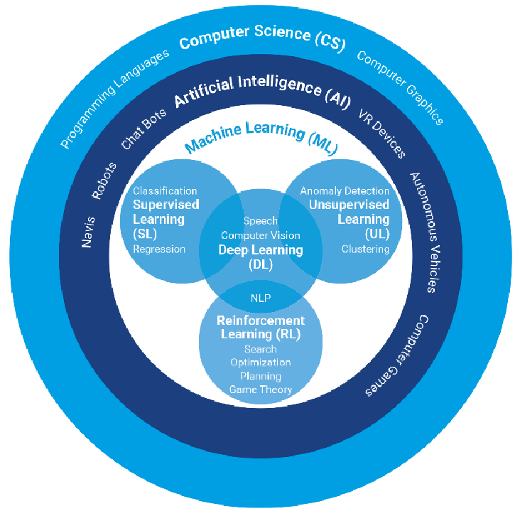

Figure1. The broader Picture of AI and Machine Learning[2].

### 1.1.2. DEEP LEARNING

New original research in any field requires an understanding of the history, evolution and major breakthroughs that led to the popularization of said field. Deep Learning is no exception[9].

A broader look at the history of Deep Learning reveals 3 major waves of advancements: Cybernetics, connectionism and deep Learning.

**a. Cybernetics**

Is the earliest predecessor of modern Deep Learning, based on the idea of biological learning — how human brains learn. Advancements done in the name of cybernetics were based on the goal to replicate the working of a human/animal brain in a simpler computational model, which would help build systems that would start learning like actual brains and provide conclusions given some input[9]. The diagram of a sample cybernetics is as shown below: 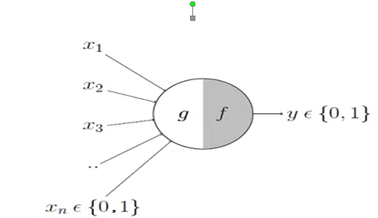

Figure 2. McCulloch-Pitts Neuron[9]

Cybernetics was kicked off by the development of the [McCulloch-Pitts Neuron](https://towardsdatascience.com/mcculloch-pitts-model-5fdf65ac5dd1#_blank)**.** It was an attempt to mimic the biological neuron. As seen on figure 2, it was based on a linear model that would take various inputs:

[X1, X2 …. Xn]

For each input the model had some weights:

[W1, W2 … Wn]

And the output:

f(x,w) = X1W1 + X2W2 + …. + XnWn.

This model could only output True/False based on the inputs and weights[9]. The weights needed to be set properly, and were input by a human manually. Later in the 1950s, [**Perceptron**](https://en.wikipedia.org/wiki/Perceptron#_blank)was developed by [Frank Rosenblatt](https://g.co/kgs/tJDU8G#_blank), an American psychologist, that would learn the weights automatically. Perceptron was initially designed to be an electrical machine rather than a program/software. Frank built Perceptron for image recognition, it contained photocells(receivers) connected to multiple neurons which would classify the inputs captured by the photocells[9].

**b. Connectionism**

[This approach](https://en.wikipedia.org/wiki/Connectionism#_blank) was inspired by cognitive sciences. Connectionism showed promise compared to various symbolic reasoning approaches scientists were exploring in the 1980s known as Classicists. Even though if we look at the brain in a more abstract view, Symbolic Reasoning approach fits well but are hard to implement explicitly using classical programmatic models. So practical connectionists viewed their work as leveraging Neural Nets to achieve similar effect as Symbolic Reasoning.[9]. But Radical Connectionist simply discarded the idea of Symbolic Reasoning stating that it could not explain various complex features of our brain anyway and was an incorrect perception of the human brain.

Concept of [Artificial Neural Network](https://en.m.wikipedia.org/wiki/Artificial_neural_network#_blank)(ANNs) was introduced during this wave. The main idea behind ANNs was to develop a network of individual units that can be programmed to achieve intelligent behavior. This was the first time the concept of hidden layers was introduced.

A network of artificial neurons connected with each other allowed parallel signal processing distributed along various branches of the network. The connections b/w the “neuron” units contained weights to control strength of the effect a neuron has on another[9]. Figure 3[9] illustrates two input layers, three hidden layers and two output layers,

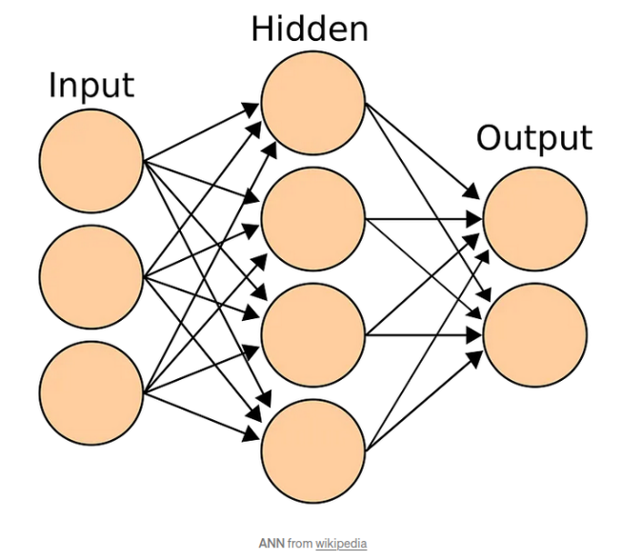

Figure 3. Artificial Neural Network(ANNs) structure[9]

This approach was perceived to be quite similar to what happens inside our nervous system and this caused some hipe among the researchers about the effectiveness of these models. During this wave of Connectionism, various models like [LSTM](https://en.wikipedia.org/wiki/Long_short-term_memory#_blank), [distributed representation and processing](https://en.wikipedia.org/wiki/Connectionism#_blank), [back-propagation](https://en.wikipedia.org/wiki/Backpropagation#_blank) to train deep neural nets were developed and continue to remain key components of various advanced applications of Deep learning to this date. But in the mid-1990s the startups based on AI started to make unrealistic claims and could never deliver that level of sophistication from these models due to the lack of computational resources. Investors pulled back and this led to dip in this second wave of Deep Learning.[9]

**c. Deep Learning**

After two dips, the third wave emerged in 2006 with a breakthrough. Geoffrey Hinton used Greedy Layer-wise Training to train [Deep Belief Networks](http://www.scholarpedia.org/article/Deep_belief_networks#_blank).[9]. In the simplest of forms the DBN’s are a composition of multiple hidden layers and each layer containing various latent variables. Connections exist b/w layers but not between the variables inside each layer. The advancements by Geoffrey Hinton were used by other researchers to train different types of Deep Networks. This enabled researcher around the world to trainer deeper and deeper neural networks and led to the popularization of the term Deep Learning.

### 1.1.3. RECURRENT NEURAL NETWORK

Recurrent Neural Network(RNN) is a type of [Neural Network](https://www.geeksforgeeks.org/tag/neural-network/) where the output from the previous step is fed as input to the current step.

**1.1.3.1. Architecture of Recurrent Neural Network**

RNNs have the same input and output architecture as any other deep neural architecture. However, differences arise in the way information flows from input to output. Unlike Deep neural networks where we have different weight matrices for each Dense network in RNN, the weight across the network remains the same. It calculates state hidden state Hi for every input Xi . **By using the following formulas:**

**h= σ(UX + Wh-1 + B)**

**Y = O(Vh + C) Hence**

**Y = f (X, h , W, U, V, B, C)**

Here S is the State matrix which has element si as the state of the network at timestep i  
The parameters in the network are W, U, V, c, b which are shared across timestep[9]. Figure 4 below illustrates better the above explanations.

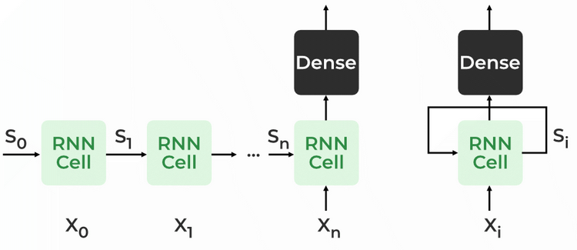

Figure 4 RNN architecture[10]

**1.1.3.2. How RNN works**

The Recurrent Neural Network consists of multiple fixed activation function units, one for each time step. Each unit has an internal state which is called the hidden state of the unit. This hidden state signifies the past knowledge that the network currently holds at a given time step. This hidden state is updated at every time step to signify the change in the knowledge of the network about the past[10]. The hidden state is updated using the following recurrence relation:-

**The formula for calculating the current state:**

$$h_{t}=f(h_{t-1}, X_{t})$$

where:

ht -> current state $+\bigcup_{1}^{n}{\cos{x}}$

ht-1 -> previous state

xt -> input state[10]

**Formula for applying Activation function(tanh):**

$$h_{t}=tanh(W_{hh}h_{t-1}, W_{Xh}X_{t})$$

where:

$W_{hh}$-> weight at recurrent neuron

$W_{Xh}$-> weight at input neuron[10]

**The formula for calculating output:**

$$y_{t}=w_{hy}h_{t}$$

Yt -> output

Why -> weight at output layer[9]

**1.1.3.3 Backpropagation Through Time (BPTT)**

In RNN the neural network is in an ordered fashion and since in the ordered network each variable is computed one at a time in a specified order like first h1 then h2 then h3 so on. Hence we will apply backpropagation throughout all these hidden time states sequentially.

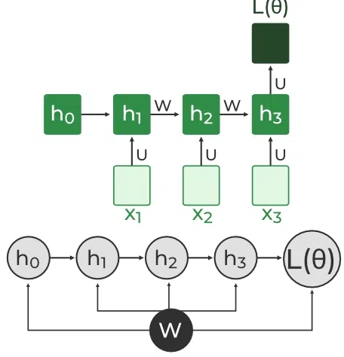

Figure 5. Backpropagation Through Time (BPTT) In RNN[10]

L(θ)(loss function) depends on h3

h3 in turn depends on h2 and W

h2 in turn depends on h1 and W

h1 in turn depends on h0 and W

where h0 is a constant starting state.

**1.1.3.4 Long Short-Term Memory (LSTM)**

[Long Short-Term Memory](https://www.geeksforgeeks.org/deep-learning-introduction-to-long-short-term-memory/) works on the read-write-and-forget principle where given the input information network reads and writes the most useful information from the data and it forgets about the information which is not important in predicting the output. For doing this three new gates are introduced in the RNN. In this way, only the selected information is passed through the network[10].

**1.1.3.5 Training through RNN**

1. A single-time step of the input is provided to the network.
2. Then calculate its current state using a set of current input and the previous state.
3. The current ht becomes ht-1 for the next time step.
4. One can go as many time steps according to the problem and join the information from all the previous states.
5. Once all the time steps are completed the final current state is used to calculate the output.
6. The output is then compared to the actual output that is, the target output and the error is generated.
7. The error is then back-propagated to the network to update the weights and hence the network (RNN) is trained using [Backpropagation](https://www.geeksforgeeks.org/ml-back-propagation-through-time/) through time.[10]

## 1.2. PRICE DEDUCTION/PREDICTION

Every business wants to make a profit. And machine learning can help. Price prediction powered by machine learning is one of the most powerful tools in any company’s toolkit. Because automated price forecasting can help us stay in sync with our market and, ultimately, improve the effectiveness of your sales process[11].

Price prediction uses an algorithm to analyze a product or service based on its characteristics, demand, and current market trends. Then the software sets a price at a level it predicts will both attract customers and maximize sales. Technical analysis looks at historical prices, economic growth rates, and other related factors, formulating an approximate price. Then, to get a more accurate picture of the market, the process turns to fundamental analysis.

This step looks at various external and internal factors, including macro-factors like the season and micro-influencers like the time of the day, trying to figure out when a consumer is most likely to buy. In mathematical terms, these processes are known as regression analysis. Which is a statistical way to predict the relationship between variables. In price prediction, price is the independent variable. And it’s affected by several dependent variables. Suppose we were trying to price a pizza: the answer would depend on the size of the pizza and the cost of its ingredients. Beyond regression, price prediction uses descriptive and [predictive analytics](https://dlabs.ai/blog/predictive-analytics-can-help-us-deliver-personalized-healthcare/). But this is just another way to describe the discrete steps of regression analysis.

This is what the two processes entail:

**Descriptive Analytics:** This step uses statistical methods of data collection, analysis, interpretation, and data visualization to look at what’s happened in the past. The historical analysis forms the basis of the predictions.

**Predictive Analytics**: This step analyzes the data to predict the possibility of future events, forecasting aspects like customer behavior.

Automated price prediction aims to develop a model capable of finding the optimal price point at any point in time without any human input. If one is looking for a reliable pricing strategy that’s rooted in data, this is the best approach. This functionality also makes use of AI and ML as well as the following algorithms:

### 1.2.1. Linear regression classifier

Linear regression is one of the easiest and most popular Machine Learning algorithms. It is a statistical method that is used for predictive analysis. Linear regression makes predictions for continuous/real or numeric variables such as **sales, salary, age, product price,** etc[12].

Linear regression algorithm shows a linear relationship between a dependent (y) and one or more independent (y) variables, hence called as linear regression. Since linear regression shows the linear relationship, which means it finds how the value of the dependent variable is changing according to the value of the independent variable. The linear regression model provides a sloped straight line representing the relationship between the variables[12].

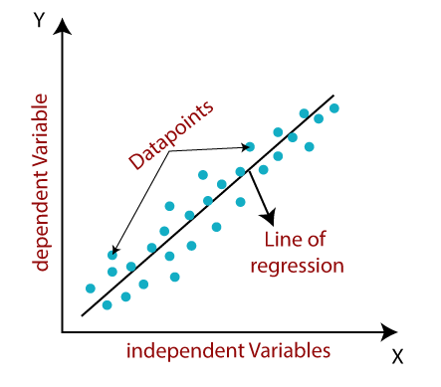

Figure 6. The linear regression line representing the relationship between the variables. [12]

$y=a_{0}+a_{1}X+$**ε**

**Here,**

Y= Dependent Variable (Target Variable)  
X= Independent Variable (predictor Variable) $a_{0}$ 
= intercept of the line (Gives an additional degree of freedom) $a_{1}$ 
 = Linear regression coefficient (scale factor to each input value).  
ε = random error

The values for x and y variables are training datasets for Linear Regression model representation.

1.2.1.1 **Linear Regression Line**

A linear line showing the relationship between the dependent and independent variables is called a **regression line**. A regression line can show two types of relationship:

* **Positive Linear Relationship:**

If the dependent variable increases on the Y-axis and independent variable increases on X-axis, then such a relationship is termed as a Positive linear relationship.

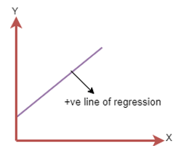

Figure 7. Linear regression line with positive relationship

* **Negative Linear Relationship:**  
  If the dependent variable decreases on the Y-axis and independent variable increases on the X-axis, then such a relationship is called a negative linear relationship. This is seen on figure 8

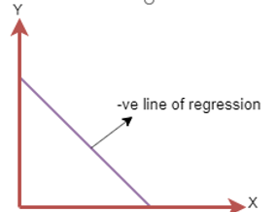

Figure 8. Linear regression line with negative relationship

**1.2.1.1.1 Finding the best fit line:**

When working with linear regression, our main goal is to find the best fit line that means the error between predicted values and actual values should be minimized. The best fit line will have the least error. The different values for weights or the coefficient of lines (a0, a1) gives a different line of regression, so we need to calculate the best values for a0 and a1 to find the best fit line, so to calculate this we use cost function.

**1.2.1.1.2. Cost function**

* The different values for weights or coefficient of lines ($a_{0}$, $a_{1}$) gives the different line of regression, and the cost function is used to estimate the values of the coefficient for the best fit line.
* Cost function optimizes the regression coefficients or weights. It measures how a linear regression model is performing.
* We can use the cost function to find the accuracy of the **mapping function**, which maps the input variable to the output variable. This mapping function is also known as **Hypothesis function**. [12]

For Linear Regression, we use the **Mean Squared Error (MSE)** cost function, which is the average of squared error occurred between the predicted values and actual values. It can be written as:

$MSE=\frac{1}{N}\sum_{i=1}^{n}{{\left(y_{i}-(a_{1}X_{i}+a_{0})\right)}^{2}}$ [12]

For the above linear equation, MSE can be calculated as:

**Where,**

N=Total number of observation $Y_{i}$ 
 = Actual value  
($a_{1}X_{i}$ + $a_{0}$) = Predicted value.

**1.2.1.1.3. Residuals:** The distance between the actual value and predicted values is called residual. If the observed points are far from the regression line, then the residual will be high, and so cost function will high. If the scatter points are close to the regression line, then the residual will be small and hence the cost function.

**1.2.1.2. Gradient Descent:**

* Gradient descent is used to minimize the MSE by calculating the gradient of the cost function.
* A regression model uses gradient descent to update the coefficients of the line by reducing the cost function.
* It is done by a random selection of values of coefficient and then iteratively update the values to reach the minimum cost function.

**1.2.3. Model Performance:**

The Goodness of fit determines how the line of regression fits the set of observations. The process of finding the best model out of various models is called **optimization**. It can be achieved by below method:

**1.2.3.1. R-squared method:**

* R-squared is a statistical method that determines the goodness of fit.
* It measures the strength of the relationship between the dependent and independent variables on a scale of 0-100%.
* The high value of R-square determines the less difference between the predicted values and actual values and hence represents a good model.
* It is also called a **coefficient of determination,** or **coefficient of multiple determination** for multiple regression.
* It can be calculated from the below formula:

$R-squared=\frac{Explained Variation}{Total Variation}$ [12]

### 1.2.3. SUPPORT VECTOR MACHINE

SVM or Support Vector Machine is a linear model for classification and regression problems. It can solve linear and non-linear problems and work well for many practical problems. The idea of SVM is simple: The algorithm creates a line or a hyperplane which separates the data into classes[13].

**1.2.3.1. SVM’s way to find the best line**

According to the SVM algorithm we find the points closest to the line from both the classes. These points are called support vectors. Now, we compute the distance between the line and the support vectors. This distance is called the margin. Our goal is to maximize the margin. The hyperplane for which the margin is maximum is the optimal hyperplane.

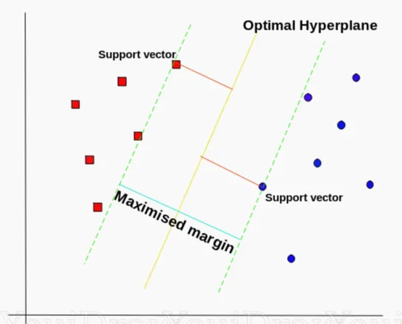

Figure 9. How SVM finds the points closest to the line from both classes. [13]

Thus SVM tries to make a decision boundary in such a way that the separation between the two classes(that street) is as wide as possible.

### 1.2.3. K-Means Clustering

K-Means Clustering is an [Unsupervised Learning algorithm](https://www.javatpoint.com/unsupervised-machine-learning), which groups the unlabeled dataset into different clusters. Here K defines the number of pre-defined clusters that need to be created in the process, as if K=2, there will be two clusters, and for K=3, there will be three clusters, and so on.[14]. It is an iterative algorithm that divides the unlabeled dataset into k different clusters in such a way that each dataset belongs only one group that has similar properties. It allows us to cluster the data into different groups and a convenient way to discover the categories of groups in the unlabeled dataset on its own without the need for any training.

It is a centroid-based algorithm, where each cluster is associated with a centroid. The main aim of this algorithm is to minimize the sum of distances between the data point and their corresponding clusters. The algorithm takes the unlabeled dataset as input, divides the dataset into k-number of clusters, and repeats the process until it does not find the best clusters. The value of k should be predetermined in this algorithm. The k-means [clustering](https://www.javatpoint.com/clustering-in-machine-learning) algorithm mainly performs two tasks:

* Determines the best value for K center points or centroids by an iterative process.
* Assigns each data point to its closest k-center. Those data points which are near to the particular k-center, create a cluster.

Hence each cluster has data points with some commonalities, and it is away from other clusters. The figure 10 below explains the working of the K-means Clustering Algorithm:

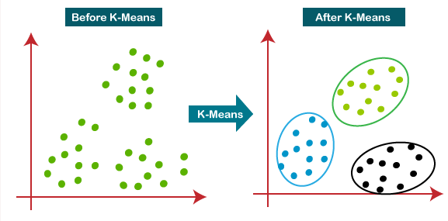

Figure 10. K-Means Clustering[14].

**1.2.3.1 How the K-Means Algorithm Works**

The working of the K-Means algorithm is as follow:

**Step-1:** Select the number K to decide the number of clusters.

**Step-2:** Select random K points or centroids. (It can be other from the input dataset).

**Step-3:** Assign each data point to their closest centroid, which will form the predefined K clusters

**Step-4:** Calculate the variance and place a new centroid of each cluster.

**Step-5:** Repeat the third steps, which means reassign each datapoint to the new closest centroid of each cluster.

**Step-6:** If any reassignment occurs, then go to step-4 else go to FINISH.

**Step-7**: The model is ready[14].

## 1.3. SENTIMENT ANALYSIS

[Sentiment analysis](https://www.paralleldots.com/sentiment-analysis#_blank) is contextual mining of text which identifies and extracts subjective information in source material, and helping a business to understand the social sentiment of their brand, product or service while monitoring online conversations. [15]

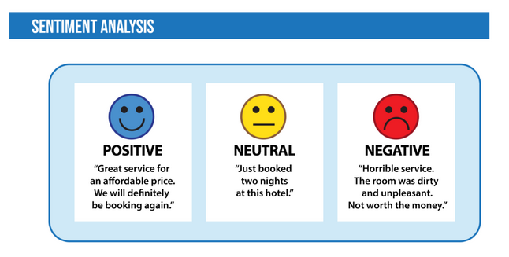

Figure 11 Sentiment Analysis.

With the recent advances in deep learning, the ability of algorithms to analyze text has improved considerably. Creative use of advanced artificial intelligence techniques can be an effective tool for doing in-depth research. We believe it is important to classify incoming customer conversation about a brand based on following lines:

1. Key aspects of a brand’s product and service that customers care about.
2. Users’ underlying intentions and reactions concerning those aspects.

These basic concepts when used in combination, become a very important tool for analyzing millions of brand conversations with human level accuracy

Sentiment Analysis is the most common text classification tool that analyses an incoming message and tells whether the underlying sentiment is positive, negative our neutral.

**Intent Analysis**

Intent analysis steps up the game by analyzing the user’s intention behind a message and identifying whether it relates an opinion, news, marketing, complaint, suggestion, appreciation or query. This sentiment analysis uses the following concepts:

### 1.3.1. Natural language processing

[Natural language processing (NLP)](https://www.deeplearning.ai/the-batch/issue-44/) is the discipline of building machines that can manipulate human language or data that resembles human language in the way that it is written, spoken, and organized[10]. It evolved from computational linguistics, which uses computer science to understand the principles of language, but rather than developing theoretical frameworks, NLP is an engineering discipline that seeks to build technology to accomplish useful tasks. NLP can be divided into two overlapping subfields: natural language understanding (NLU), which focuses on semantic analysis or determining the intended meaning of text, and natural language generation (NLG), which focuses on text generation by a machine. NLP is separate from but often used in conjunction with speech recognition, which seeks to parse spoken language into words, turning sound into text and vice versa[16].

**1.3.1.1** **How Does Natural Language Processing (NLP) Work?**

NLP models work by finding relationships between the constituent parts of language — for example, the letters, words, and sentences found in a text dataset. NLP architectures use various methods for data preprocessing, feature extraction, and modeling. Some of these processes are:

1.3.1.1.1 **Data preprocessing:** Before a model processes text for a specific task, the text often needs to be preprocessed to improve model performance or to turn words and characters into a format the model can understand. Various techniques may be used in this data preprocessing:

1.3.1.1.2 [**Stemming and lemmatization**](https://nlp.stanford.edu/IR-book/html/htmledition/stemming-and-lemmatization-1.html): Stemming is an informal process of converting words to their base forms using heuristic rules. For example, “university,” “universities,” and “university’s” might all be mapped to the base univers. Stemming and lemmatization are provided by libraries like spaCy and NLTK.

1.3.1.1.3 [**Sentence segmentation**](https://www.crimsoni.ai/katana/) breaks a large piece of text into linguistically meaningful sentence units. This is obvious in languages like English, where the end of a sentence is marked by a period, but it is still not trivial. A period can be used to mark an abbreviation as well as to terminate a sentence, and in this case, the period should be part of the abbreviation token itself. The process becomes even more complex in languages, such as ancient Chinese, that don’t have a delimiter that marks the end of a sentence.

1.3.1.2 [**Stop word removal**](https://www.ibm.com/docs/en/watson-explorer/11.0.0?topic=analytics-stop-word-removal)aims to remove the most commonly occurring words that don’t add much information to the text. For example, “the,” “a,” “an,” and so on.

1.3.1.3 [**Tokenization**](https://neptune.ai/blog/tokenization-in-nlp) splits text into individual words and word fragments. The result generally consists of a word index and tokenized text in which words may be represented as numerical tokens for use in various deep learning methods. Figure 12 illustrates the above explanations.

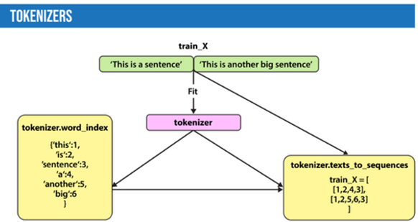

Figure 12 Demonstrations of how text are being tokenized [16]

1.3.1.4 **Feature extraction:** Most conventional machine-learning techniques work on the features – generally numbers that describe a document in relation to the corpus that contains it – created by either Bag-of-Words, TF-IDF, or generic feature engineering such as document length, word polarity, and metadata (for instance, if the text has associated tags or scores). More recent techniques include Word2Vec, GLoVE, and learning the features during the training process of a neural network.

1.3.1.5. **Bag-of-Words:** Bag-of-Words counts the number of times each word (combination of n words) appears in a document. For example, below, the Bag-of-Words model creates a numerical representation of the dataset based on how many of each word in the word_index occur in the document.

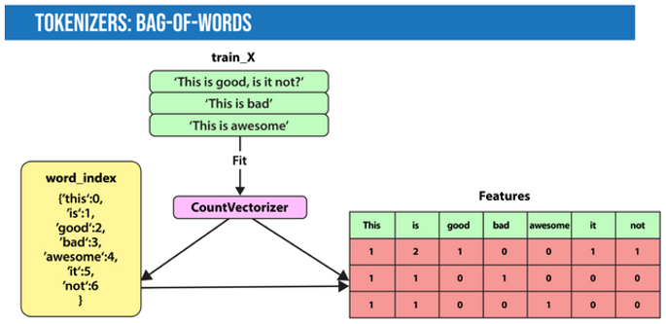

Figure 13. Bag-of-words through the countVectorizer Methods[17]

**TF-IDF:** In Bag-of-Words, we count the occurrence of each word or n-gram in a document. In contrast, with TF-IDF, we weight each word by its importance. To evaluate a word’s significance, we consider two things:

**Term Frequency:** How important is the word in the document?

TF(word in a document)= Number of occurrences of that word in document / Number of words in document

**Inverse Document Frequency:** How important is the term in the whole corpus?

IDF(word in a corpus)=log(number of documents in the corpus / number of documents that include the word)

A word is important if it occurs many times in a document. But that creates a problem. Words like “a” and “the” appear often. And as such, their TF score will always be high. We resolve this issue by using Inverse Document Frequency, which is high if the word is rare and low if the word is common across the corpus. The [TF-IDF](https://deeplearning.ai/the-batch/bug-squasher/) score of a term is the product of TF and IDF[16]. The figure 14 below throws more light on the above explanation.

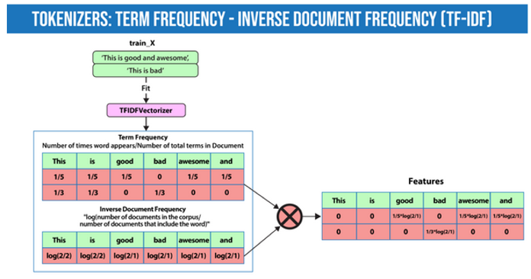

Figure 14. How TF-IDF creates features for each documents based on how often each word shows up in a document versus the entire corpus[17].

**Word2Vec**: [introduced in 2013](https://deeplearning.ai/the-batch/how-to-keep-up-in-a-changing-field/), uses a vanilla neural network to learn high-dimensional word embeddings from raw text. It comes in two variations: Skip-Gram, in which we try to predict surrounding words given a target word, and Continuous Bag-of-Words (CBOW), which tries to predict the target word from surrounding words. After discarding the final layer after training, these models take a word as input and output a word embedding that can be used as an input to many NLP tasks.

**Modeling:** After data is preprocessed, it is fed into an NLP architecture that models the data to accomplish a variety of tasks.

**Language Models**: In very basic terms, the objective of a language model is to predict the next word when given a stream of input words. Probabilistic models that use Markov assumption are one example:

P(Wn)=P(Wn|Wn−1)

### 1.3.2. ALGORITHMS USED WITH THE NLP IN THE PROJECT:

**1.3.2.1. Naive Bayes Classifier**

Naïve Bayes algorithm is a supervised learning algorithm, which is based on **Bayes theorem** and used for solving classification problems[14].

* It is mainly used in text classification that includes a high-dimensional training dataset.
* Naïve Bayes Classifier is one of the simple and most effective Classification algorithms which helps in building the fast machine learning models that can make quick predictions.
* It is a probabilistic classifier, which means it predicts on the basis of the probability of an object.
* Some popular examples of Naïve Bayes Algorithm are **spam filtration, Sentimental analysis, and classifying articles**.

**1.3.2.1.1. Bayes' Theorem:**

* Bayes' theorem is also known as **Bayes' Rule** or **Bayes' law**, which is used to determine the probability of a hypothesis with prior knowledge. It depends on the conditional probability.
* The formula for Bayes' theorem is given as:

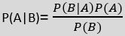 [14]

**Where,**

**P(A|B) is Posterior probability**: Probability of hypothesis A on the observed event B.

**P(B|A) is Likelihood probability**: Probability of the evidence given that the probability of a hypothesis is true.

**P(A) is Prior Probability**: Probability of hypothesis before observing the evidence.

**P(B) is Marginal Probability**: Probability of Evidence.

[**Naive Bayes**](https://scikit-learn.org/stable/modules/naive_bayes.html) finds the conditional probability distribution P(label | text) using the following Bayes formula:

P(label | text) = P(label) x P(text|label) / P(text)

and predicts based on which joint distribution has the highest probability. The naive assumption in the Naive Bayes model is that the individual words are independent. Thus:

P(text|label) = P(word_1|label)*P(word_2|label)*…P(word_n|label)

In NLP, such statistical methods can be applied to solve problems such as spam detection or [finding bugs in software code](https://deeplearning.ai/the-batch/bug-squasher/).

1.3.2.2. [**Hidden Markov models**](https://towardsdatascience.com/markov-and-hidden-markov-model-3eec42298d75)**:** Markov models are probabilistic models that decide the next state of a system based on the current state[17]. The figure 15 below shows the states transitions for a simple Markov models.

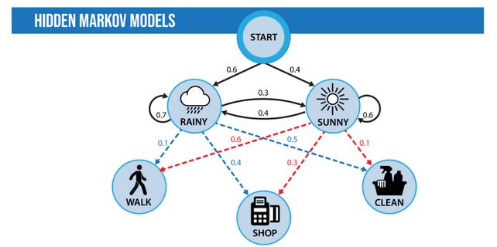

Figure 15. Hidden Markov models demonstration[17]

## 1.4. CHATBOTS

A chatbot is a computer program that uses [artificial intelligence](https://www.ibm.com/topics/artificial-intelligence#_blank) (AI) and [natural language processing](https://www.ibm.com/topics/natural-language-processing#_blank) (NLP) to understand customer questions and automate responses to them, simulating human conversation.[18]. Chatbots can make it easy for users to find the information they need by responding to their questions and requests through text input, audio input, or both—without the need for human intervention. Historically, chatbots were text-based, and programmed to reply to a limited set of simple queries with answers that had been pre-written by the chatbot’s developers. They operated like an interactive FAQ, and while they worked well for those specific questions and answers on which they had been trained, they failed when presented with a complex question or one that hadn’t been predicted by the developers. Over time, chatbots have integrated more rules and natural language processing, so end users can experience them in a conversational way. In fact, the latest types of chatbots are contextually aware and able to learn as they’re exposed to more and more human language.

Today’s AI chatbots use natural language understanding (NLU) to discern the user’s need. Then they use advanced AI tools to determine what the user is trying to accomplish. These technologies rely on [machine learning](https://www.ibm.com/topics/machine-learning#_blank) and [deep learning](https://www.ibm.com/topics/deep-learning#_blank) elements of AI, [with some nuanced differences](https://www.ibm.com/cloud/blog/ai-vs-machine-learning-vs-deep-learning-vs-neural-networks#_blank) to develop an increasingly granular knowledge base of questions and responses that are based on user interactions. This improves their ability to predict user needs accurately and respond correctly over time.[18]

### 1.4.1 Common Chabot Uses

Consumers use AI chatbots for many kinds of tasks, from engaging with mobile apps to using purpose-built devices such as intelligent thermostats and smart kitchen appliances. Business use is equally varied. [Marketers](https://www.ibm.com/watson-advertising/thought-leadership/what-is-conversational-marketing#_blank) use AI chatbots to personalize customer experiences, IT teams use them to enable self-service, and customer contact centers rely on chatbots to streamline incoming communications and direct customers to resources.[18]. Conversational interfaces can vary, too. AI chatbots are commonly used in social media messaging apps, standalone messaging platforms, or applications on websites.

### 1.4.2 Benefits of chatbots

The latest AI chatbots process the data within human language to deliver highly personalized experiences, creating clear benefits for businesses and customers.

* **Improve customer engagement and brand loyalty**
* **Generate leads and satisfy customers**
* **Reduce costs and boost operational efficiency**

The following concepts were used to realize this chat-bot: NLP, CNN.

### 1.4.3. CONVOLUTIONAL NEURAL NETWORK(CNN)

A CNN is a class neural networks that specializes in processing data that has a grid-like topology such as an image[19].

**1.4.3.1 Convolutional Neural Network Architecture**

A CNN typically has three layers: a convolutional layer, a pooling layer, and a fully connected layer.[19]. Figure 16 shows an overview of CNN architecture.

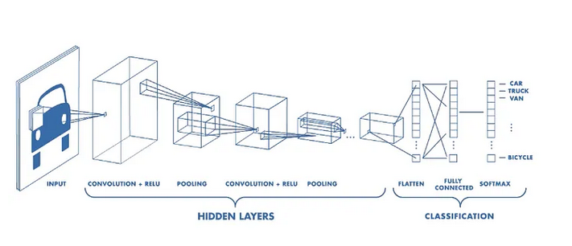

Figure 16. Convolutional Neural Network Architecture[19]

**1.4.3.2. Convolution Layer**

The convolution layer is the core building block of the CNN. It carries the main portion of the network’s computational load. This layer performs a dot product between two matrices, where one matrix is the set of learnable parameters otherwise known as a kernel, and the other matrix is the restricted portion of the receptive field. [19]

If we have an input of size W x W x D and $D_{out}$ number of kernels with a spatial size of F with stride S and amount of padding P, then the size of output volume can be determined by the following formula[19]:

$$W_{out}=\frac{W-F+2P}{S}+1$$

**1.4.3.3 Pooling Layer**

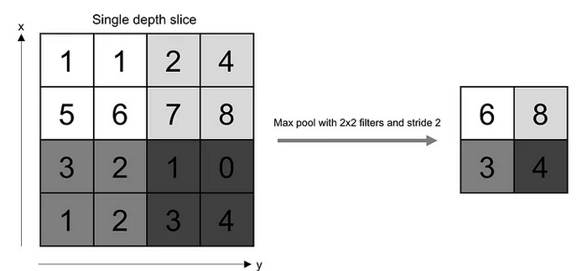The pooling layer replaces the output of the network at certain locations by deriving a summary statistic of the nearby outputs. This helps in reducing the spatial size of the representation, which decreases the required amount of computation and weights. The pooling operation is processed on every slice of the representation individually[19]. There are several pooling functions such as the average of the rectangular neighborhood, L2 norm of the rectangular neighborhood, and a weighted average based on the distance from the central pixel. However, the most popular process is max pooling, which reports the maximum output from the neighborhood. Figure 17 demonstrates the above explanations.

Figure 17. Pooling Operation (Source: O’Reilly Media[8])

If we have an activation map of size W x W x D, a pooling kernel of spatial size F, and stride S, then the size of output volume can be determined by the following formula[19]:

$$W_{out}=\frac{W-F}{S}+1$$

This will yield an output volume of size $W_{out}$ x $W_{out}$ x D.

In all cases, pooling provides some translation invariance which means that an object would be recognizable regardless of where it appears on the frame[7].

**1.4.3.3 Fully Connected Layer**

Neurons in this layer have full connectivity with all neurons in the preceding and succeeding layer as seen in regular FCNN. This is why it can be computed as usual by a matrix multiplication followed by a bias effect[19]. The FC layer helps to map the representation between the input and the output.

**1.4.3.4 Non-Linearity Layers**

Since convolution is a linear operation and images are far from linear, non-linearity layers are often placed directly after the convolutional layer to introduce non-linearity to the activation map.[19]. There are several types of non-linear operations, the popular ones being:

**1. Sigmoid**

The sigmoid non-linearity has the mathematical form[19]:

$$σ\left(κ\right)=\frac{1}{1+e^{-k}}$$

It takes a real-valued number and “squashes” it into a range between 0 and 1

**2. Tanh**

Tanh squashes a real-valued number to the range [-1, 1]. Like sigmoid, the activation saturates, but unlike the sigmoid neurons its output is zero centered[19]

**3. ReLU**

The Rectified Linear Unit (ReLU) has become very popular in the last few years. It computes the function[19].

$$ƒ(κ)=max (0,κ).$$

In other words, the activation is simply threshold at zero. In comparison to sigmoid and tanh, ReLU is more reliable and accelerates the convergence by six times.

## 1.5. Literature review

In this section of the dissertation, a critical review is expressed on the work of [Yves R Sagaert](https://www.researchgate.net/profile/Yves-Sagaert-2)[20] titled “Tactical sales forecasting using a very large set of macroeconomic indicators” and published in June 2017 from the VIVES University of Applied Sciences. There, he used multiple approaches to improve tactical sales forecasting using macro-economic leading indicators. However, limited work has been done on the level of using the sales history of enterprise to forecast the next month sales. This also extend the work of [PeerJ Comput Sci](https://www.ncbi.nlm.nih.gov/pmc/articles/PMC8114814/)[21] titled “News sensitive stock market prediction” published in may 4 2021. In his findings, he investigated the significance of using structured text features rather than unstructured and shallow text features. His work was based on*:*

1. A thorough research review for stock trend prediction in three areas*:*

* 1. Study of stock trend prediction based on financial time series data and preprocessing of financial data.
  2. Research based on text preprocessing and feature extraction techniques.
  3. Investigation about prediction algorithms to analyze the influence of textual and numerical features on the stock market.

1. Based on reviewed literature, solutions are identified that guide to resolve challenges found in the generic phases of a stock prediction task.
2. Discussion about open issues and research directions, which can be further investigated and explored by the community.

However, limited work was done on predicting prices of goods which depend on certain factors that vary within the period of the year.

In addition, this work also extend the work of Gil Maria dos Santos Romão[22] titled “chat-bots in education” published in June 2021 from Catholic University of Mozambique. He is work was limited to educational purposes without thinking about industries, how chat-bot can also be implemented in industries.

Although the need for a AI is gradually seeping into the interests of industries, community, much research has not been done about this all-important topic, as evidenced in just a few availabilities of previous literature. This makes it a daunting task to research on the topic but motivated by the works of Gil Maria dos Santos Romão[22], [PeerJ Comput Sci](https://www.ncbi.nlm.nih.gov/pmc/articles/PMC8114814/)[21], and [Yves R Sagaert](https://www.researchgate.net/profile/Yves-Sagaert-2)[20].

This dissertation will create and train ML models to be able to forecast companies’ sales (that is, extending the work of [Yves R Sagaer*t*](https://www.researchgate.net/profile/Yves-Sagaert-2)[20] to enterprises ) and predict prices of their goods (that is, extending the work of [PeerJ Comput Sci](https://www.ncbi.nlm.nih.gov/pmc/articles/PMC8114814/)[21] to predict prices of goods), create an AI-driven sentiment analysis to be able to feel clients’ emotions, whether they are happy or not after buying a product from an industry, create a chat-bot to give automatic responses to clients in the absence of employees in an industry ( that is, extending the work of Gil Maria dos Santos Romão[22] to help industries rather than just focusing on educational purposes).

## 1.6. Presentation of the enterprise EHSS SARL

To have the solutions to our questions, the research dissertation was carried out at the enterprise Engineering Hard and Soft Solution EHSS. Her descriptions and objectives will be discussed in this subsection. EHSS is a research and development, valorization of innovation created by the Business partners. It was born from the desire to value everything that is done as research, whether as part of students' end-of-study projects or more research articles likely to be valued by companies. EHSS is also specialized in IT and AI development and the creation of specific software, dedicated to a business. It was found in 2017 and it’s located at “Ange Raphael” Next to the university of Douala. Her goal is also to promote the development of solutions to solve local problems.

### 1.6.1. Other objectives and services

The company has based its know-how and its reputation on rigorous functional and technical analyses, based on your needs and the understanding of the business process. A team of confirmed programmers, perfectly mastering the different programming languages, is committed to developing applications according to the rules of the art. Experienced project manager supports by following, step by step, a proven project management methodology. Some major goals are:

- Development of web and mobile applications

- Deployment of ERP solutions

- Cabling and Administration

- Training and awareness

- IT infrastructure management and maintenance

- Implementation of backup solutions and disaster recovery plans

- Fleet management

- AI application development

### 1.6.2. Organizational structure

The EHSS company does not yet have a structure in place. However, in depending on the evolution of its activities, it has a set of partners and of partners whose said presence will subsequently make it possible to set up an organizational chart functional allowing it to be properly structured.

**1.6.2.3. Her partners**

As partners and associates of the EHSS company, we can mention:

SUITE NOVATEL, BIENTINO SARL, KMD, DOVV, BOUPI&F, DNGA&FILLS, E.LECLEC, GROUP SABC.

# Chapter 2: Materials and Methods

## 2.1. Methodology

This section of the research work outlines the approach used in achieving the set objectives. The section is presented in the following subsections; dataset, the general approach, and finally, technology and hardware systems used to carry out the project.

### 2.1.1. DATASET

The primary aim of this research is to make enterprises optimize their profit. In this regard, the techniques and the algorithms were applied on the EHSS sarl dataset. The dataset was imported from company’s database on cloud where all their data is saved, to the local machine where it was manipulated. The dataset was imported in the form a sql file which contains 97 tables with each table containing about 1000000 rows. This is the database they have been using for years and it contains all the sales history of their customers. Specific features as seen on figure 18 were extracted from the database[4], analyzed and processed based on the need.

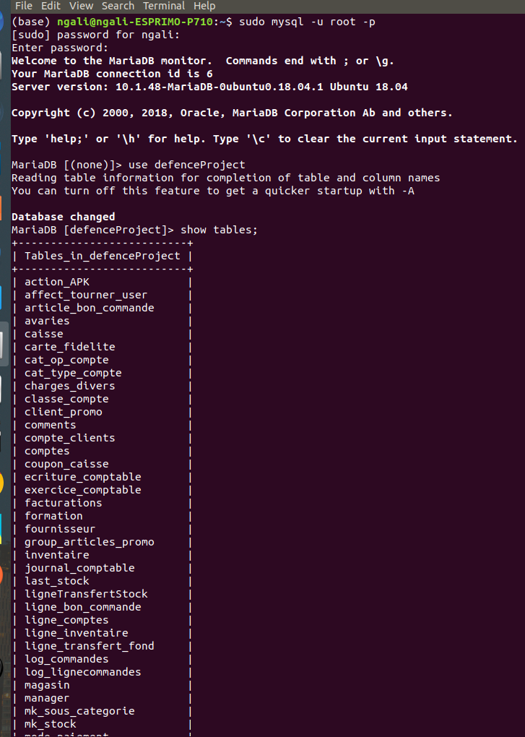

Figure 18. EHSS database[4]

### 2.1.2 The General Approach in building the four models

This subsection outlines the general AI approach adopted in the series of experimentations in order to build the four models. This section is divided into four subsections:

**2.1.2.1. Sales Forecasting**

In this subsection, we will explain how the model that is able to forecast the sales was built. The sale history dataset was used in training the model. The data science workflow was used to better organize the work and also to give the model an outstanding performance. The first step was to prepare, explore, visualize and clean the data. The concepts of RNN was used here.

**2.1.2.1.1. Data Preparation and Pre-processing**  
In most instances of machine learning projects, the datasets used do not come in a form appropriate enough to assist in building trustworthy models; in this regard, data preparation and preprocessing are key as they allow us to get the data in a format suitable for building models that lead to accurate insights.

From the imported database, the features with the sales history from 2017 to 2023 were exported into a pandas data-frame for processing. This means that the last seven years data were used to train the model that will be able to forecast the future sales. These data were thoroughly cleaned during the processing phase before fitting it in to the model for training. This was done to improve the performance of the model. The variation of the sales with time was studied. This made me acquired the domain knowledge about the company’s sales so that if the model is in a bad state, it would be easily troubleshooted. The variation of their sales for the last 6 years is shown in figure 19.

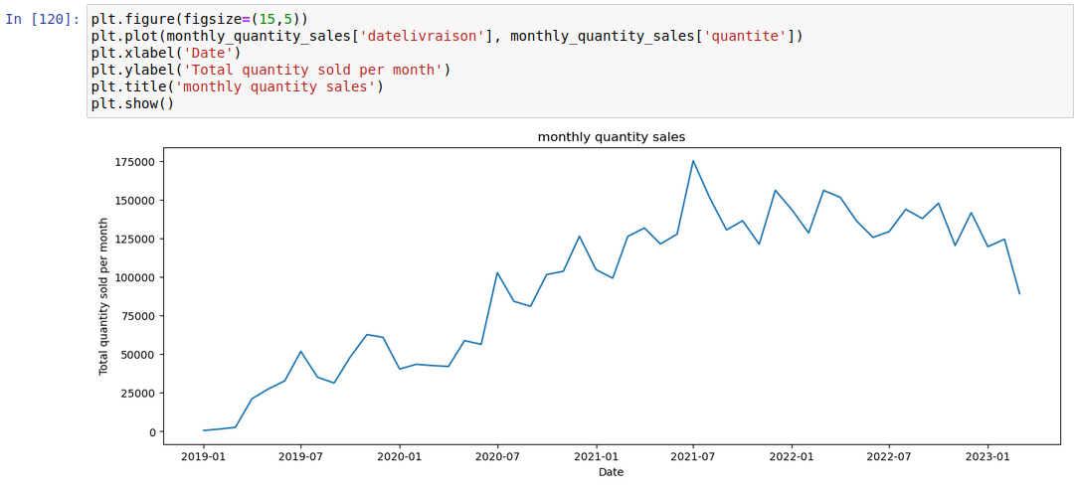

Figure 19. The variation of the annual sales with time-frame

The data were shifted so that for each month, we get the last three month sales. This was done so that the model could learn a pattern from this variation. It is shown on figure 20.

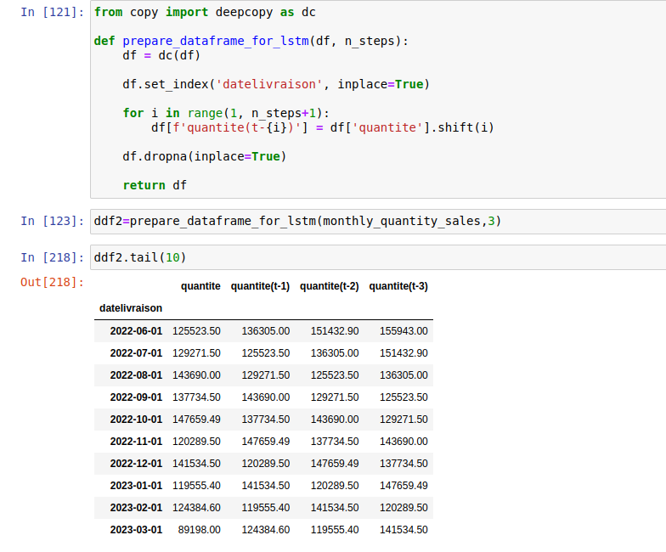

Figure 20. Shifted dataset for the model.

**2.1.2.1.2. Training the sales forecasting model**

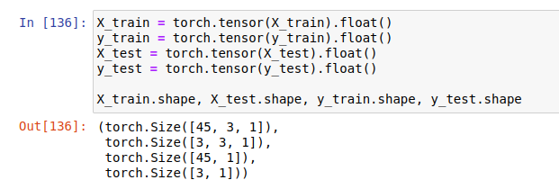In this subsection, we will explain how this model was trained. After which the data were prepared, the data was split into training and testing set where the last five years sales history were used to train the model and the recent two years sales were used for testing the model. The model was trained using LSTM with one input layer, four hidden layers and one output layer. Since my data was a time series data, LSTM was used because I have a long-term trend in my data and the LSTM cell adds long-term memory in an even more performant way because it allows even more parameters to be learned. This makes it the most powerful RNN to do forecasting. Figure 21 shows how the data were split into training and testing set.

Figure 21. splitting the data in to training and testing set.

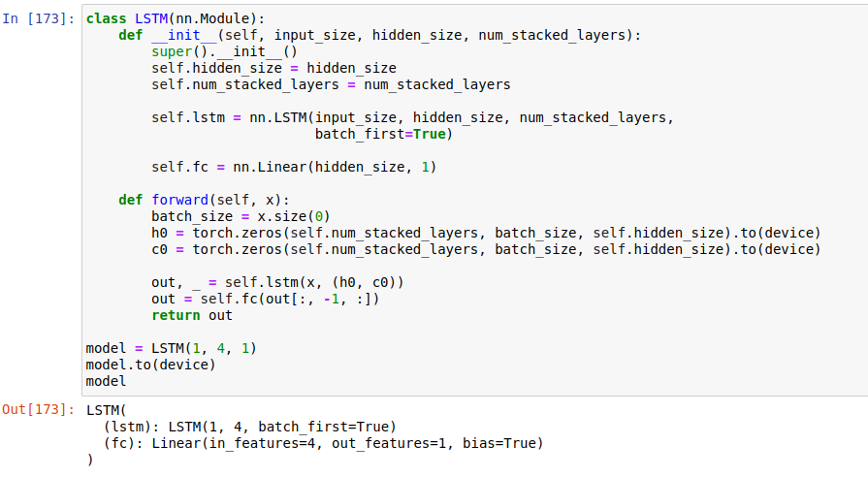After splitting the data, the LSTM model was prepared which is shown in figure 22

Figure 22. Preparation of LSTM model.

**2.1.2.1.3. Increasing the model performance**

The performance of the model was increased with the use of the following:

**- Normalization:** the data was normalized within -1,1 using the MinMaxScaler.The goal of normalization is to transform features to be on a similar scale. This improves the performance and training stability of the model.

**- Number of epochs the epochs number was 5000.** Increasing the number of epochs in a neural network can have a positive impact on the accuracy of the model. By exposing the algorithm to the same data multiple times, the algorithm can learn from the data and improve its accuracy.

**- Learning rate:** different learning rates were chosen and the one that gave the best loss was 0.01. See appendix 1 for epochs validation and the learning rate implementation.

**2.1.2.1.3. The model accuracy**

After training, the model accuracy was tested to be 92% as seen on figure 23

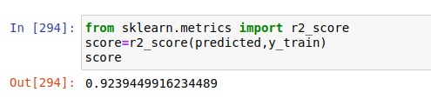

Figure 23. The accuracy of the sales forecasting model

**2.1.2.1.4. Visualization of the results.**

The model was tested with the last two years’ sales and the graph of actual and expected sales was plotted as shown on figure 24.

Figure 24. Visualization of the actual and predicted sales.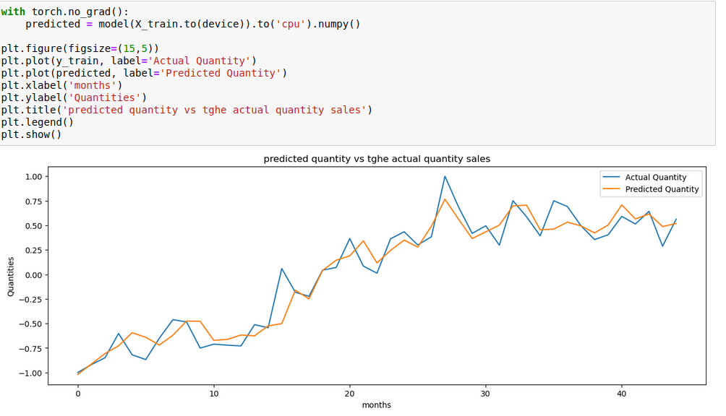

**2.1.2.1.5. Saving the LSTM model.**

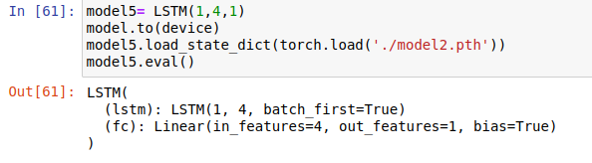The state dictionary of the model was saved using .pth format , and was loadedwithload_state_dict() for evaluation. This is shown in figure 25.

Figure 25. loading the state dictionary of the LSTM model.

This model could now be loaded by the user, and use it for forecasting which was 92% accurate.

**2.1.2.2. PRICE PREDICTION/DEDUCTION**

In this subsection, we will explain how the model that is able to predict or deduct the products prices was built. In the ehss database, the tarticles table was used in training the model. The data science workflow was used to better organize the work and also to give the model an outstanding performance. This subsection will be divided into steps. The first step in this subsection was to Identify the problem.

**2.1.2.2.1. DATA PROCESSING AND VISUALIZATION**

STEP1: IDENTIFYING THE PROBLEM WE WANNA SOLVE, GET, PREPARE AND EXPLORE THE DATA CONCERN.

The goal is to see:

* the products that give more impact on the overall profit.
* the category of the article that give more impact on the overall profit.
* the types of the article that give more impact on the overall profit.
* decision on the promotion price to optimize profits.
* decision on the products’ prices to optimize profits.

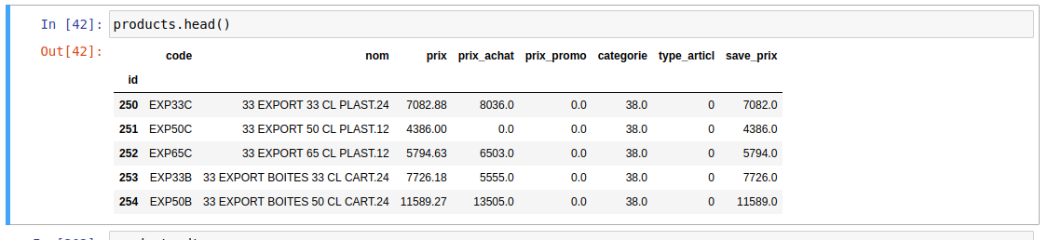After identifying the problem, data were exported from the database into the pandas data-frame for processing, and the specific features from the tarticles tables were taken for exploration. The features considered were: id_article, nom_article, prix, prix_achat, prix_promo, categorie_article, type_article and then the save_prix(the labels). Figure 26 shows a sample of data preparation.

Figure 26. Data preparation for price deduction model

STEP 2: CLEANING THE DATA

In this subsection, the null values in the data were replaced by np.nan and then extrapolated, the missing values in the data were guessed using the domain knowledge while some were replaced by the mode of the data column. outliers were also removed, and the data were distributed normally.

STEP 3: VISUALIZING THE DATA

In this subsection, the correlation amongst the features were identified and the descriptive statistics for each features were determined. This is shown in figure 27

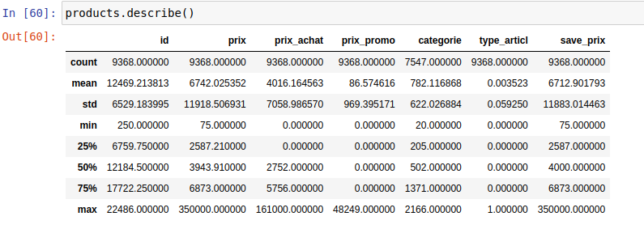

Figure 27. The descriptive statistic of the selected features.

That was followed by the visualization with the boxplot as seen on figure 28

Figure 28. Boxplot that shows the impact the Type_article has on our labels.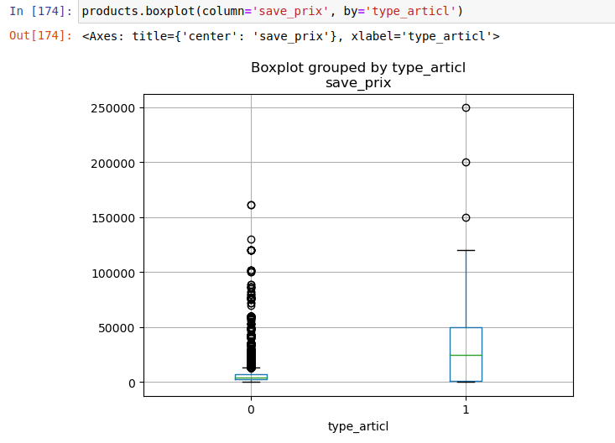

The next step of visualization was to determine the level in which each product impacts the label data. The findings is shown in figure 29.

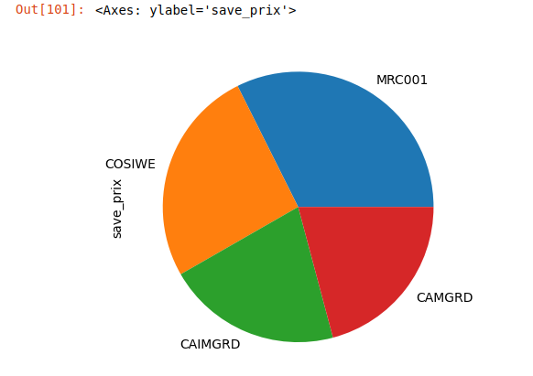

Figure 29. Pie chart that shows the level each product type impacts the labels.

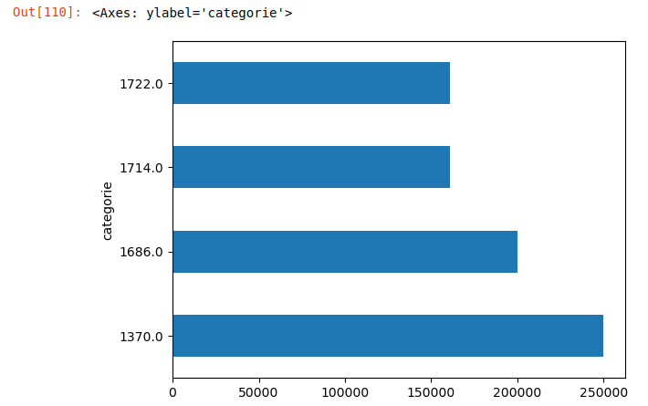The bar chat in figure 30 was used to determine my what amount these features impacted the label data.

Figure 30. Illustration of the best four categories that increase the company’s profit

The correlation between the “prix” and the label was determine which is shown in figure 31

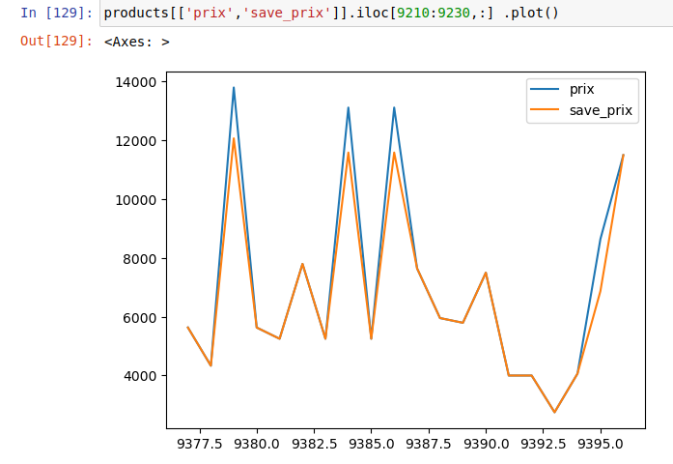

Figure 31. THE CORRELATION BETWEEN THE SAVE_prix AND THE PRICE

**2.1.2.2.2. Building a machine learning model to predict/deduct the save_prix of an article.**

After exploring the database getting the insight, it is time tobuild a ML model that can predict the save_prix

**Step 1: FEATURES SCALING**

After visualizing the features, this step was done to improve the accuracy and the performance of the model. The data were scaled between 0 and 1. To do this, the data were Standardized.

**step 2: FEATURE SELECTION**

At this point, we selected the best features that have great impact on the save_price(the label).

a. Removing the Quasi constant features

To select the best features, it was importance to remove the quasi features. Quasi Constant Features are those that show the samevalue for a great majority of observations in the dataset. Type_article was identified as a quasi feature, so, it was removed from the list of features used 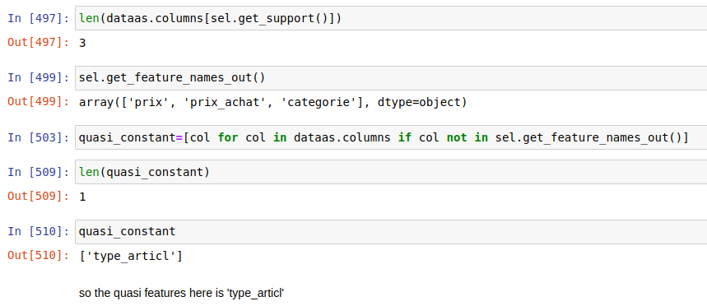in training the model. This is shown in figure 32

Figure 32. Identifying the quasi features

**b. Removing the correlated features**

In this step, the correlated features were removed and thethree best features for the model were identified to be: prix, prix_achat, categorie_article. This shown in figure 33

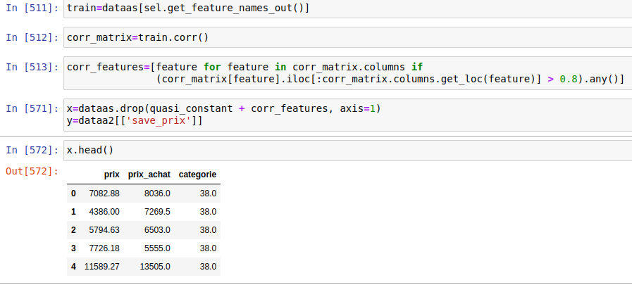

Figure 33. The three best features for the model.

**Step 3: splitting the data into the training and testing set.**

In this step, 80% of the data were used to training the model and 20% for testing. This was to feed the model with more data for it to learn from many pattern and increase its performance. The random state was set to 42 to get the same train and test sets across different executions.

**Step 4: MODEL SELECTION**

Since we have many machine-learning algorithm, the choice of getting the appropriate one for a particular problem was problematic. In this step, out of the numerous ML algorithms, the model that gave a better prediction/deduction was identified. To begging this step, the label data was cut into bins to turn a regression problem into a classification problem. Figure 34 shows how this was done.

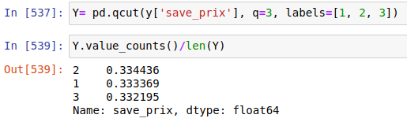

Figure 34. Cutting the label data into bins

This data was then fed into three different models to see which one gives the best score. These models were: LinearRegression(lr), supportVectorMachine(svm) and K- nearestNeighbor(KNN). After feeding the data into these models. The linear regression showed the best performance with an accuracy of 99%, followed by KNN with an accuracy of 98% and lastly the SVM had an accuracy of 96%. Figure 35 illustrates the above explanations.

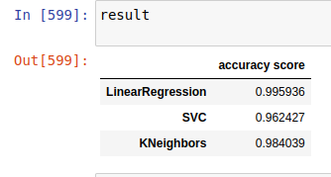

Figure 35. Figuring the best model.

See appendix 2 for more Code implementation. Since the lr had the best performance, it was then used to train the model.

**Step 5: Using the Linear Regression to train the model.**

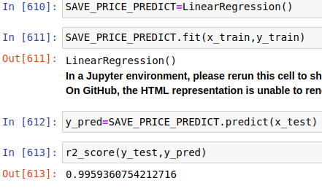The training dataset was then fitted into the linear regression model for training and then saved using joblib and .pickel format. This is shown in figure 36.

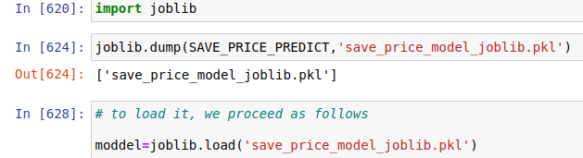Figure 36. Price deduction model training and accuracy

Figure 37. Saving the price prediction model.

**2.1.2.3. SENTIMENT ANALYSIS**

This section helps the enterprise to know the state of a customer after buying a product. Was he happy or sad? Was he satisfied or not? Knowing this state will permit the enterprise to increase the quality of their products if the clients were not satisfied after buying. The concepts of NLP were used in this section. To be able to realize this, the data was gotten from kaggle. The following samples were downloaded: twitter_samples'), averaged_perceptron_tagger, wordnet, stopwords. The twitter_samples contains the negative and the positive tweets.

Figure 38 shows how the data was gotten from kaggle.

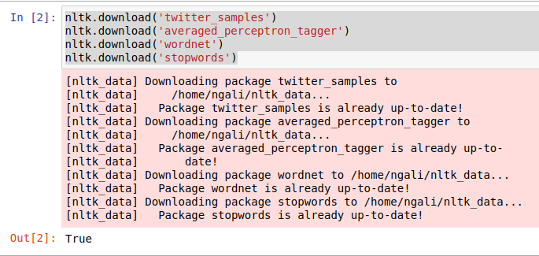Figure 38. Data source for sentiment analysis.

**Step 1: Extracting the positive and the negative tweets**

After downloading the twitter_sample, the positive and the negative tweets were then extracted from it while ignoring the tweets with no sentiment.

**Step 2:** **Tokenize the tweets**

To make processing easier, the individual word from the positive and negative tweets were Tokenized. This is shown in figure 39

Figure 39. Tokenizing the the tweets

**Step 3: Remove noise from data**

Tokens that do not add value in the analysis were removed. These are token like:

* + Twitter usernames (starting with @)
  + Hyperlinks (starting with http:// or https://)
  + Punctuation and special characters
  + numeric values
  + stopwords(words that have a little meaning on their own for instance: is, the, a, for)

figure 40 shows how the data was cleaned.

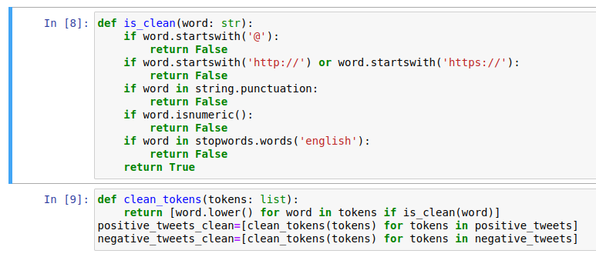Figure 40. Data cleaning for sentiment analysis model

### Step 4: Normalizing the data

Here, words were converted into canonical form. That is, the words were being lemmatized. This helps the algorithm to identify that, words like “ran”, “runs”, and “running” are same words.

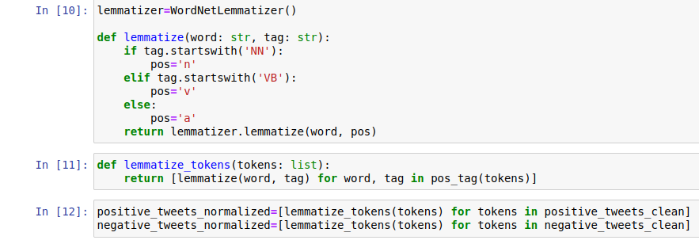

Figure 41. Normalizing the sentiment analysis data.

**Step 5: Prepare data for Model**

After normalization, the **set of positive and negative tweets were taken. For example, the normalized tweet: ['hopeless', 'tmr', ':(']** became **({'hopeless': True, 'tmr': True, ':(': True}, 'Negative').**

**Step 6: Prepare training and test dataset**

**A dataset of the combined positive and negative datasets was made and after that, it was shuffled. The training dataset was the first 7000 entries and the test dataset was the remaining entries. Figure 42 shows how the data was prepared.**

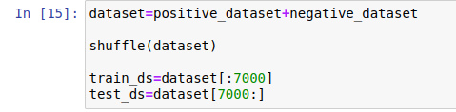

Figure 42.Preparing data from naive baye classifier model

**Step 6: Train and test Model**

After which the data was prepared, the NaiveBayesClassifier was then used to train the model. This model got an accuracy of 99% as shown in figure 43.

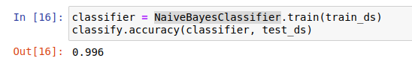

Figure 43. Using NaiveBayesClassifier to train the model.

The model was then save using the pickel file.

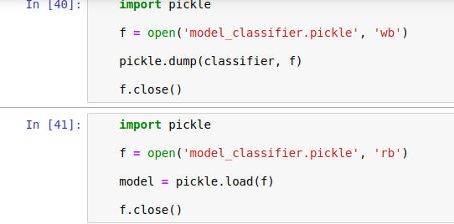

Figure 44. Saving the sentiment analysis model

**Step 7: Testing the model**.

The model was then tested which gives positive for positive sentiment and negative for negative sentiment.

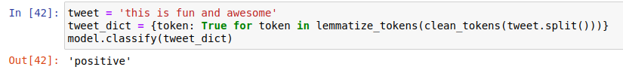Figure 45. Testing the sentiment analysis model

**2.1.2.4. CHATBOT**

This section optimizes enterprise’s activities. Instead of employing people to constantly respond to client’s questions, a chatbot will rather do so, which saves the company some cash. It optimizes her activities in the sense that clients will get automatic responses to their questions and the system will be available 24/7. Overall, the aim of this section is to build a chatbot model that will be able to give automatic responses to specific questions of an enterprise to clients in need. The concepts of NLP and CNN were used in this section. This section is divided into steps in order to achieve the above objectives.

**Step 1: Getting data**

The data used to build this chat-bot were all possible questions that can come from the clients, together with all possible answers. These data were gotten from the CEO of EHSS sarl.

**Step 2: Assembling the questions and the answers**

After collecting the data, the pair of a question and its corresponding answer were grouped into a JSON file. A question is identified by a pattern while its corresponding answer is identified by a response. This json file contains certain categories of things that can happen. For example, the user can greet a chatbot, the user can ask questions about the prices of the articles, he can say goodbye. These are different categories of things provided with tag, and for each tag, we also specified patterns like “greetings”. Essentially, a couple of example on a how the user could greet the chatbot was provided to the chatbot, and it takes that as a training data in other to learn how it could be greeted. A collection of static responses were also provided to a specific pattern.

The whole assemble (question and corresponding answer) were identified by a tag. Here is a sample. This chat-bot was trained for it to be able to understand what the user is trying to get from it. And if he recognizes that, he will generate static responses to these questions. This is a sample in figure 46.

Figure 46. sample json file containing a question and its corresponding answer

**Step 3: Tokenizing and lemmatizing the words**

After grouping this data into a single tag, the next step was to tokenize and lemmatize the whole file. After lemmatizing, words like works, worked, working, work were identified as same word ignoring the punctuations. What word tokenizing does is, it takes a sentence and split it into individual word. See appendix 3 for the code implementation.

**Step 4: preparing data for neural networks**

After step 3, the next thing was to prepare the data for training. Up to now, what we have is text data, but the neural network takes numerical data. So, these tokenized and lemmatized words were converted in to numerical values. Individual word indices were converted into either 0 or 1 depending on whether it’s occurring in that particular pattern. This numerical data was then shuffled as training data and converted into a numpy array. This shuffled numpy array was then split into training and testing data. Figure 47 shows how the data was prepared for the CNN.

Figure 47. Data preparation for the CNN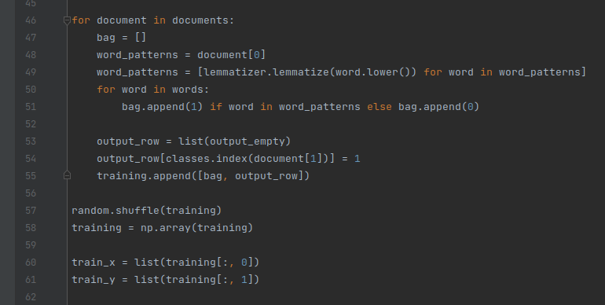

**step 5: Building the neural networks model**

In this step, a neural network model was built. This was done on a sequential model. The first layer is a dense layer with 128 neurons, with input shapes which has the length of the training data (the x_train) and an activation function of Rectified Linear Unit (relu). The dropout was 0.5 to prevent over fitting. The hidden layers followed after the dense layer with 64 neurons and a dropout of 0.5. The output layer was also a dense layer with the length of the training data (y_train) as the number of neurons and the activation function was softmax (this allows the scaling of results in the output layers so that they could sum up to one).The next thing was to define a stochastic gradient descent (SGD) optimizer with learning rate of 0.01, a decay of 1e-6, and finally a momentum of 0.9. The model was then compiled with the loss function of categorical_crossentropy, optimizer of SGD and a metrics of accuracy. After compilation, the model was the fitted with the training data (x_tarin), epochs of 5000 and a batch size of 5 and finally a verbose of 1 and then saved as chatbot_model.h5. how the sequential model was set up is shown in figure 48.

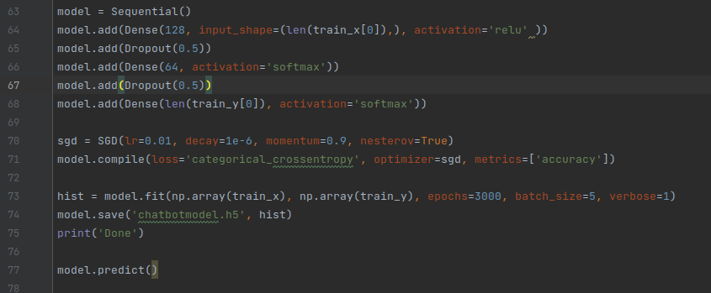

Figure 48. The sequential model for training the chatbot model.

### 2.1.3. CONCEPTION OF THE APPLICATION THAT INTEGRATES AI

In this section, the AI application that uses the trained models was built. This section is divided into three subsections. The overview and modeling of the application, the UI (user interface) and the API. The UI is used by the clients to put the data into the models while the API takes the data and load the models, takes back the results and display to the user. This API will be able to call an HTTP request made from the UI to the models and bring back the response. This API is used as the back-end of the UI application while the UI will be used as the front-end. Here is an overview:

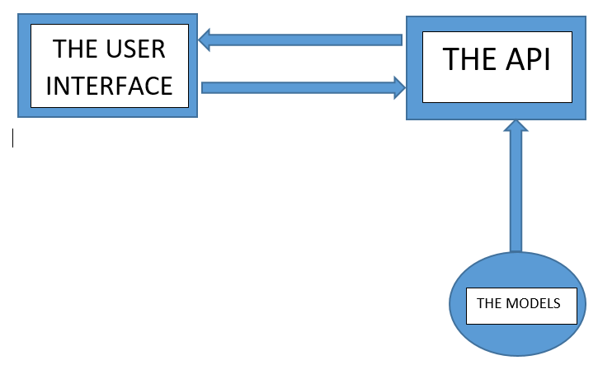

Figure 48. Overview of the application.

**2.1.3.1. Overview and modeling of the application**

In this subsection, we bring to light the structure of the application. The users of this application are the manager and his clients. The manager has access to the sales forecasting model where he is able to forecast his future sales as well as price prediction model where he predicts the articles’ prices. On the other hand, the clients are able to comment about a product and get inquiries. If the client objective is to report about a product, he will meet a sentiment analyzer and base on the comment of the client, the sentiment analyzer will be able to tell whether the client is happy or not. If he is happy, a joyful message will be displayed to him by the application, otherwise a consolidation message will be displaced to him while sending an email containing the client comment and also informing the manager about the quality update of that particular product.

figure 49 shows the states and behavior of the application with the help of UML class diagram.

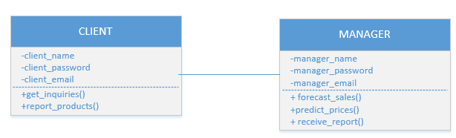

Figure 49. UML class diagram of the application

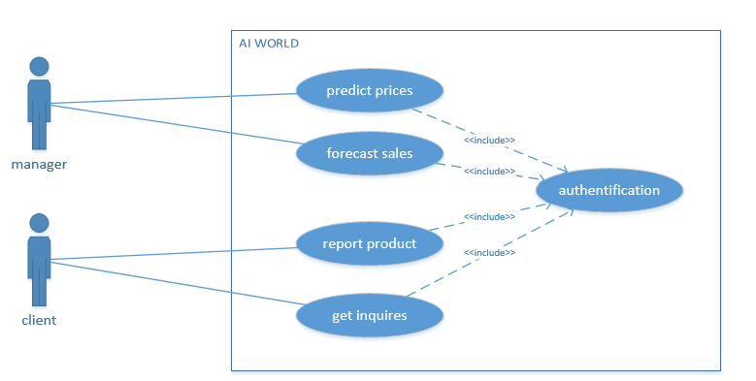Furthermore, both the clients and the manager must be authentified before having access to these models. The client and manager are identified by their name, password and email address. Figure 50 is the UML usecase diagram of the above process.

Figure 50. The usecase diagram of AI world

The interaction between the actor in which in this case is the client and the use cases (comment product and get inquiries) on the application is presented figure 51, which illustrates the sequence diagram of the above process.

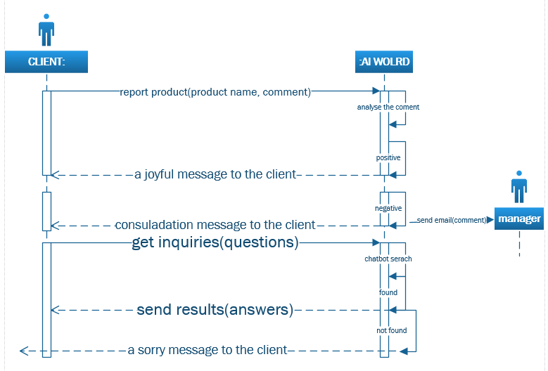

Figure 51. The UML sequence diagram for the client’s side of the application.

The interaction between the application and the manager is presented with a UML sequence diagram in figure 52.

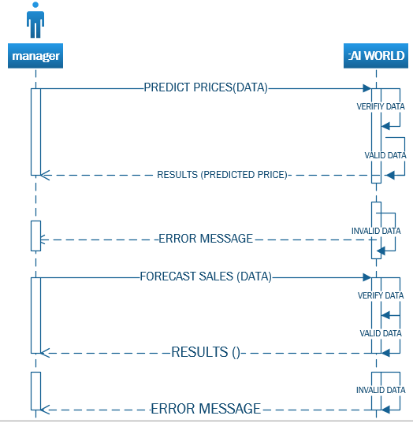

Figure 52. The UML sequence diagram for the manager’s side of the application

**2.1.3.2. The user interface(UI)**

This section is used by the client to be able to access the built models. The clients connect to the application and input the data from the UI. An http call is then made by the API to load the model. Below is a sample for a chatbot. See appendix 4 for the code implementation

**2.1.3.3. The API**

This section safe as an http endpoint. It makes an http call from the UI and use the data gotten to load the models. This is a sample for a chatbot. See appendix 5 for the code implementation.

**2.1.3.4. Agile Methodology**

As a development methodology, agile was considered. Agile methodology is a project management approach that prioritizes cross-functional collaboration and continuous improvement. It divides projects into smaller phases and guides teams through cycles of planning, execution, and evaluation.

2.1.3.4.1**. The benefits of using Agile methodology**

Agile is one of the most popular approaches to project management because it is flexible, it is adaptable to changes and it encourages customer feedback. Agile approach was embraced for the following reasons:

* **Rapid progress:** By effectively reducing the time it takes to complete various stages of a project, teams can elicit feedback in real time and produce working prototypes or demos throughout the process
* **Customer and stakeholder alignment:** Through focusing on customer concerns and stakeholder feedback, the Agile team is well positioned to produce results that satisfy the right people
* **Continuous improvement:** As an iterative approach, Agile project management allows teams to chip away at tasks until they reach the best end result

## 2.2. Presentation of Materials

### 2.2.1. Technology and Systems used.

The programming language and environment, main software packages used as well as the specifications of the system hardware used in carrying out the experiments are briefly described in this subsection

**2.2.1.1. Software Used**

**2.2.1.1.1 python 3.8.8**  
Python 3.8.8 programming language running in Jupyter Notebook 6.3.0 on Anaconda 3 was used to carry out the research. Python was specifically chosen for this project due to its high level of readability and maintenance which has made it a popular language among developers.  
Again, the choice of python over the other programming languages for this project was motivated by its advantage being able to run on a wide variety of hardware platforms with almost the same interface and also its broad standard library compatibility on all of these different platforms. Most python libraries were used to establish this project.

**2.2.1.1.1.1. Scikit-learn 0.24.1**

**Scikit-learn 0.241** was one of the key python libraries used to perform the series of experiments. It is a free to use machine learning library within the python programming language. It comes with several algorithms that are useful for classification, clustering and regression among many other machine learning purposes. The tools used in data preparation and preprocessing relied greatly on the scikit-learn library. Again, the linear regression, svm, KNN, MinMaxscaler as well as the accuracy score GridSearchCV and RFECV optimisation techniques  
used training the price prediction model and feature selection were all implemented from the scikit library. More so, the metrics used in evaluating the model’s fit and also for testing accuracy relied on this library. The choice of scikit-learn over the other python libraries for this project work was informed by the spread of machine learning algorithms coupled with the tools that comes with it such as the cross-validation tool for evaluation of accuracy of models on unseen data which has made its usage popular among developers. It is important to note as early mentioned that most of the important tools required to carry out the project were already  
available in the scikit-learn library.  
The linear regression, svm and KNN classification algorithm implemented in the price prediction experiment were provided by the **Scikit-learn** library in python. This is a prebuilt binary wheel available from  
Python Package Index (PyPI). The biggest reason why I chose linear regression models over other ML algorithms is its linearity: **It makes the estimation procedure simple** and, most importantly, these linear equations have an easy to understand interpretation on a modular level (i.e. the weights). This is a key motivation for its implementation in this project work over the other machine learning algorithms.   
Other libraries such as pandas 1.2.4, numpy 1.19.5 and scipy , mathplotlib were also used in the experimentation based on their proven roles in data science projects.

**2.2.1.1.1.2. Pytorch 2.0**

Pytorch was one of the key python libraries used to perform the series of experiments. PyTorch is an open source machine learning (ML) framework based on the Python programming language and the Torch library. Torch is an open source ML library used for creating deep neural networks and is written in the Lua scripting language. It was the main python framework used in the sales forecasting experiment to train the model. It was used because:

* it Enables easy [debugging](https://www.techtarget.com/searchsoftwarequality/definition/debugging) with popular Python tools.
* I found it easy-to-learn, simple-to-code structure that's based on Python.
* It offers scalability and is well-supported on major cloud platforms.
* It provides a small community focused on open source.
* It exports learning models to the Open Neural Network Exchange (ONNX) standard format.
* It offers a user-friendly interface.

PyTorch's popularity continues to rise, as it simplifies the creation of artificial [neural network](https://www.techtarget.com/searchenterpriseai/definition/neural-network) models. PyTorch is mainly used by data scientists for research and artificial intelligence ([AI](https://www.techtarget.com/searchenterpriseai/definition/AI-Artificial-Intelligence)) applications.

**2.2.1.1.1.3. TensorFlow 2.0**

Tensorflow was one of the key python libraries used to establish this task. It was entirely used to build the chatbot model. TensorFlow is an end-to-end AI platform and collection of dependencies created by Google that eases the computations involved in the development of ML models. TensorFlow is a rich system for managing all aspects of a machine learning system; however, this class focuses on using a particular TensorFlow API to develop and train machine learning models. TensorFlow's high-level APIs are based on the Keras API standard for defining and training neural networks. Keras enables fast prototyping, state-of-the-art research, and production—all with user-friendly APIs. TensorFlow APIs are arranged hierarchically, with the high-level APIs built on the low-level APIs. The figure 53 shows the hierarchy of TensorFlow toolkits:

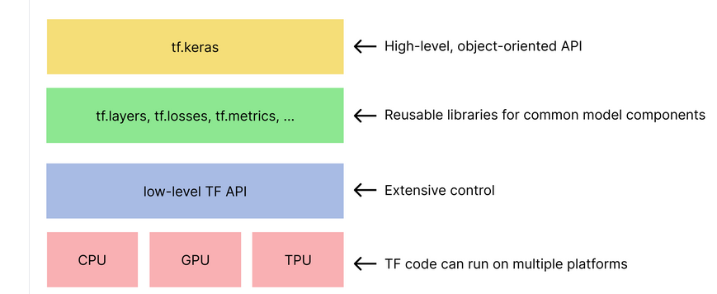

Figure 53. TensorFlow toolkit hierarchy.[23]

TensorFlow library was used in this chat-bot construction because of its Good Computational **Graphs.** **The Graphs dashboard in TensorBoard is an effective tool for reviewing a TensorFlow** model. In addition, its Seamless Library Management was superb. Domain-specific application packages were accessed that extend TensorFlow and look through libraries to build complex models or methodologies. Moreover, the tensorFlow was used here because of its scalability just like pytorch, its keras friendly as well as its Hands-on Debugging features.

**2.2.1.1.1.4. NATURAL LANGUAGE TOOLKIT(NLTK)**

**NLTK was one of the tools used in this dissertation. It was used to build a sentiment analysis model and the chatbot model.**

**The Natural Language Toolkit (NLTK) is a platform used for building Python programs that work with human language data for applying in statistical natural language processing (NLP). It contains text processing libraries for tokenization, parsing, classification, stemming, tagging and semantic reasoning. It also includes graphical demonstrations and sample data sets as well as accompanied by a cook book and a book which explains the principles behind the underlying language processing tasks that NLTK supports.**

**The Natural Language Toolkit is an open source library for the Python programming language originally written by Steven Bird, Edward Loper and Ewan Klein for use in development and education.[24]**. **NLTK was used because It is free and open-source, so its source code and documentation were accessed, modified, and distributed without any restrictions or fees. Also, It has a large and diverse collection of corpora and lexical resources, such as WordNet, Brown Corpus, Gutenberg Project, and Movie Reviews. However, one I did not like about nltk was its speed and implementation when building the models.**

**2.2.1.1.1.5. PYTHON FLASK**

This was one of the tools used in this dissertation. Python flask was used to build the API, that is the http endpoint. Python flask takes the data from the UI and use it to load the model. Flask is **a** widely used micro web framework for creating APIs in Python. It is a simple yet powerful web framework that is designed to get started quickly and easily, with the ability to scale up to complex applications [25]. [Flask](https://www.mygreatlearning.com/blog/everything-you-need-to-know-about-flask-for-beginners/#_blank) was created by Armin Ronacher. Flask is considered a micro web framework is written in Python programming. The word “micro” means focusing to keep the core extensible but straightforward. It is not dependent upon external libraries to perform the tasks of a framework. Flask framework is more independent, flexible, and simple.[26]

Flask was used to build this http endpoint because of it is f**lexibility and scalability. Flask supports WSGI templates that help in flexibility and scalability in the web development process. Also, it was used because of its compatibility with the latest technologies such as machine learning, agile development, cloud technologies, etc. in addition, because of its Integrated Unit Testing, it was preferred to django. Flask offers an integrated unit testing feature that helps in faster debugging, robust development, and independence to do experiments. Finally, because of its lightweight features, it was chosen in this dissertation. Flask is a lightweight framework because it is independent of external libraries and it gives a quick start for web development having complex applications.**



Figure 54. Python flask frameworklogo[26]

**1.6 Anaconda3**

This was the main tool in this project. All the python libraries were installed and used in anaconda3 environment. In fact, anaconda3 was the main python interpreter. Software in anaconda like the jupyter notebook was the main playground for data processing.

Anaconda Python is a free, open-source platform that allows the writing and execution of code in the programming language Python. It is by continuum.io, a company that specializes in Python development. The Anaconda platform is the most popular way to learn and use Python for scientific computing, data science, and machine learning. It is used by over [thirty](https://www.anaconda.com/blog/10-years-of-data-science-innovation-anacondas-commitment-to-the-open-source-python-community)[million people](https://www.anaconda.com/blog/10-years-of-data-science-innovation-anacondas-commitment-to-the-open-source-python-community#_blank) worldwide and is available for Windows, macOS, and Linux.[27]

This tool was used because it simplifies package deployment and management. It also comes with a large number of libraries/packages that one can use for projects. Since Anaconda Python is free and open-source, anyone can contribute to its development. Anaconda software helped me create an environment for many different versions of Python and package versions. Anaconda was also used to install, remove, and upgrade packages in this project environments.

**2.2.1.1.2. Postman**

Postman is one of the tools used. It was used to test the http request from the from the API before implementation. This was to make debugging easy. Postman is an API platform for building and using APIs. Postman simplifies each step of the API lifecycle and streamlines collaboration to create a better and faster API**.** The Postman Sandbox is a JavaScript execution environment that's available while writing pre-request and test scripts for requests (both in Postman and Newman).[28]

**2.2.1.1.3. Microsoft Visio**

MS visio was used to draw the UML diagram during the modeling phase of the application. Visio is an excellent diagramming tool for professional use. It is powerful, easy to use, and has a large library of templates and shapes that make creating diagrams and flowcharts easy and fast.[29]

**2.2.1.1.4. Cascading Style Sheets(CSS)**

This was one of the tools used in this project. It was used to design the UI of the apllication. CSS was developed by **W3C** ([World Wide Web Consortium](https://www.w3.org/#_blank)) in 1996 for a rather simple reason. HTML element was not designed to have tags that would help format the page. developers were only supposed to write the markup for the web page.[30]. CSS is used to stylize elements written in a markup language such as HTML. It separates the content from the visual representation of the site. The relation between HTML and CSS is strongly tied together since HTML is the very foundation of a site and CSS is all of the aesthetics of an entire website.[30]

**2.2.1.1.5. HyperText Markup Language(html)**

HTML was greatly used in this thesis. It was one of the tools used in building the UI. HTML is a standardised system for tagging text files that creates the structure for just about every page that we find and use on the web. HTML adds in page breaks, paragraphs, bold lettering, italics, and more. HTML works to build this structure by using tags that tell browsers what to do with text. HTML works by using a series of tags to inform a browser what it should be doing with text on page and where it should be loading further resources from. The first version of HTML was written by Tim Berners-Lee in **1993**. Since then, there have been many different versions of HTML.[31]

**2.2.1.1.6. JavaScript**

JavaScript was one of the tools used in building the UI of this project. It also played a vital role in forwarding data to the API. JavaScript takes the data from the UI and forwards to the API while the API then uses it to load the models. JavaScript is a lightweight programming language that web developers commonly use to create more dynamic interactions when developing web pages, applications, servers, and or even games. It is a scripting language for creating dynamic web page content. It creates elements for improving site visitors’ interaction with web pages, such as dropdown menus, animated graphics, and dynamic background colors.

**2.2.1.1.7. PowerBI Desktop**

This tool took part in data cleaning when building the sales forecasting and price prediction models. This tool was used together with pandas to give a better accuracy to the models by cleaning the data. Power BI Desktop is a free application that is installed on a local computer that lets us connect to, transform, and visualize our data. With Power BI Desktop, one can connect to multiple different sources of data, and combine them (often called modeling) into a data model. This data model lets one build visuals, and collections of visuals we can share as reports, with other people inside our organization. Most users who work on business intelligence projects use Power BI Desktop to create reports, and then use the Power BI service to share their reports with others.[32]

**8. Pycharm**

This was the main code editor that was used to carry out the project. This code editor was used when building the API and the models. PyCharm is a dedicated Python Integrated Development Environment (IDE) providing a wide range of essential tools for Python developers, tightly integrated to create a convenient environment for productive Python, web, and data science developmen[33]

**9. Visual Studio Code**

This tool assisted the Pycharm. This code editor was used when building the UI.

Visual Studio Code is a free, lightweight but powerful source code editor that runs on our desktop and on the web and is available for Windows, macOS, Linux, and Raspberry Pi OS. It comes with built-in support for [JavaScript](https://www.infoworld.com/article/3441178/what-is-javascript-the-full-stack-programming-language.html), [TypeScript](https://www.infoworld.com/article/3538428/what-is-typescript-strongly-typed-javascript.html), and [Node.js](https://www.infoworld.com/article/3210589/what-is-nodejs-javascript-runtime-explained.html) and has a rich ecosystem of extensions for other programming languages (such as C++, C#, Java, Python, PHP, and Go), runtimes (such as .NET and Unity) environments (such as Docker and Kubernetes), [34]

**2.2.1.2. System Hardware Used**  
The experiments embodied in this dissertation were performed on a workstation running ubuntu OS, with 7-core (24 with hyperthreading) Intel Xeon 2620 V3 with each running at 2.4GHz and 15M cache Skt2011 processor. Also, the workstation used in this project had a total of 32GB (4 x8GB) DDR4 2133MHz ECC registered memory. Other components of the workstation include a 500GB 6Gb/s 2.5” hard disk, 2 x Hitachi 2TB 7200rpm 6Gb/s. It is important to note that no other computationally intensive processes were run concurrently and also the experiments were run sequentially

# Chapter 3: Results and Discussion

## 3.1. Results

This section of the dissertation presents the findings made from the series of experimentations performed. It also seeks to discuss the findings based on other previous works in the literature.  
The order of the presentation is in line with the objectives set for this dissertation. What this means is that, the results is presented based on the four thematic topics of this dissertation  
which include; the sale forecasting model which forecast the future sales of enterprises there by optimizing their profit, the price deduction/prediction models that predicts the articles’ prices that vary in function of certain factors, the sentiment analyzer that analyzes the status of customers after purchasing a product, and finally the chatbot that discuss with customers. The presentation follows with a general overall summary of the findings and a general discussion on the move towards a better AI world.

### 3.1.1. Sales Forecasting

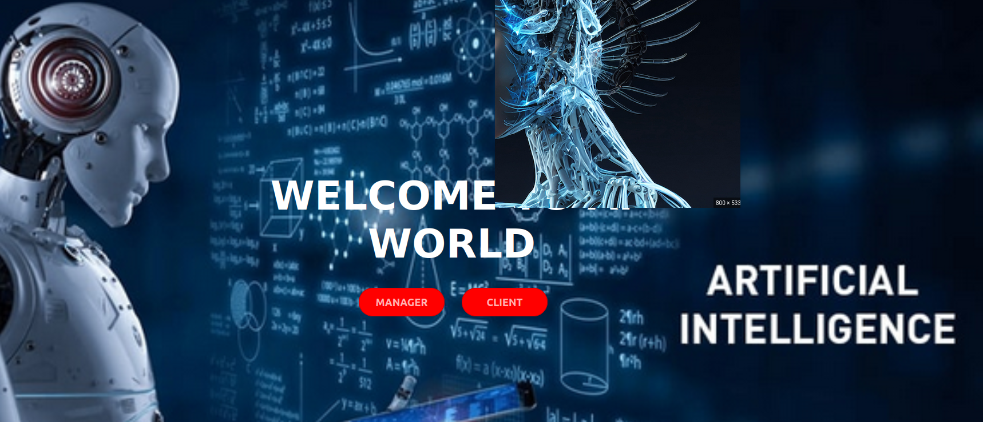The sales forecasting model was setup to be a business helper. As earlier mentioned in the methodology (See section 2.1), the purpose of the sales forecasting model was to actually help organizations forecast their future sales based on their sales history. With this, they will be able to implement certain strategies to reach their target sales. To explains briefly its functionalities, the CEO of an enterprise connect to the application, registered if he or she does not have an account, or login directly if he or she has. Figure 55 is the interface of the home page.

Figure 55. The home page of AI world

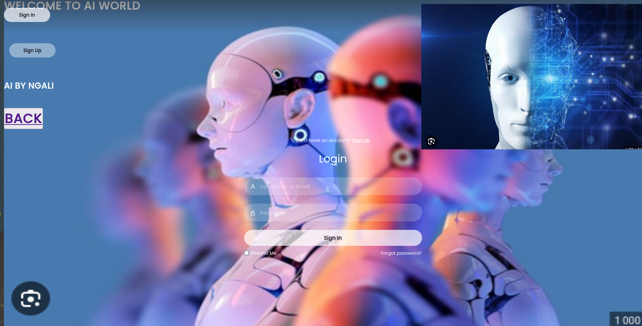Here the CEO will choose the manager section and the application will send him to the manager registration page where he either registers if he does not have an account of login if he has. Figure 56 is the manager registration page.

Figure 56. The manager registration page

The manager logins or register on this page. From here, the applications sends him to the page where he will choose the sales forecasting side if he wanted to forecast his future sales. Figure 56 shows this interface.

Figure 57. Choosing between the sales forecasting and price predicting side of the application.

From here, if the manager chooses the sale forecasting side of the application, he will be sent where he will meet the sales forecasting model. Here is the interface of the sale forecasting model.

Figure 58. The sales forecasting interface

Here the CEO will provide the following data to be able to forecast his future sales; the last month sales, the sales of the company two months ago, the sales of the company three months ago, and finally his expected sales. The model will use this as testing data and then generate the forecasted sales.

The work did not end at the level of forecasting the sales only. The model should be able to tell him the best product to achieve his objective sales as well as the best client to sell these products to and obtain the forecasted sales by studying the last month statistics. Furthermore, the model should be able to tell if he can get the expected sales or not by checking the possibilities. The model compares the expected sales to the forecasted sales to be able to tell the possibilities. It is possible if the expected sales is less than or equal to forecasted sales and vice versa. This improves the work of Yves R. Sagaert [20] (see section 1). This system was not implemented in their projects.

### 3.1.2. Price deduction/prediction

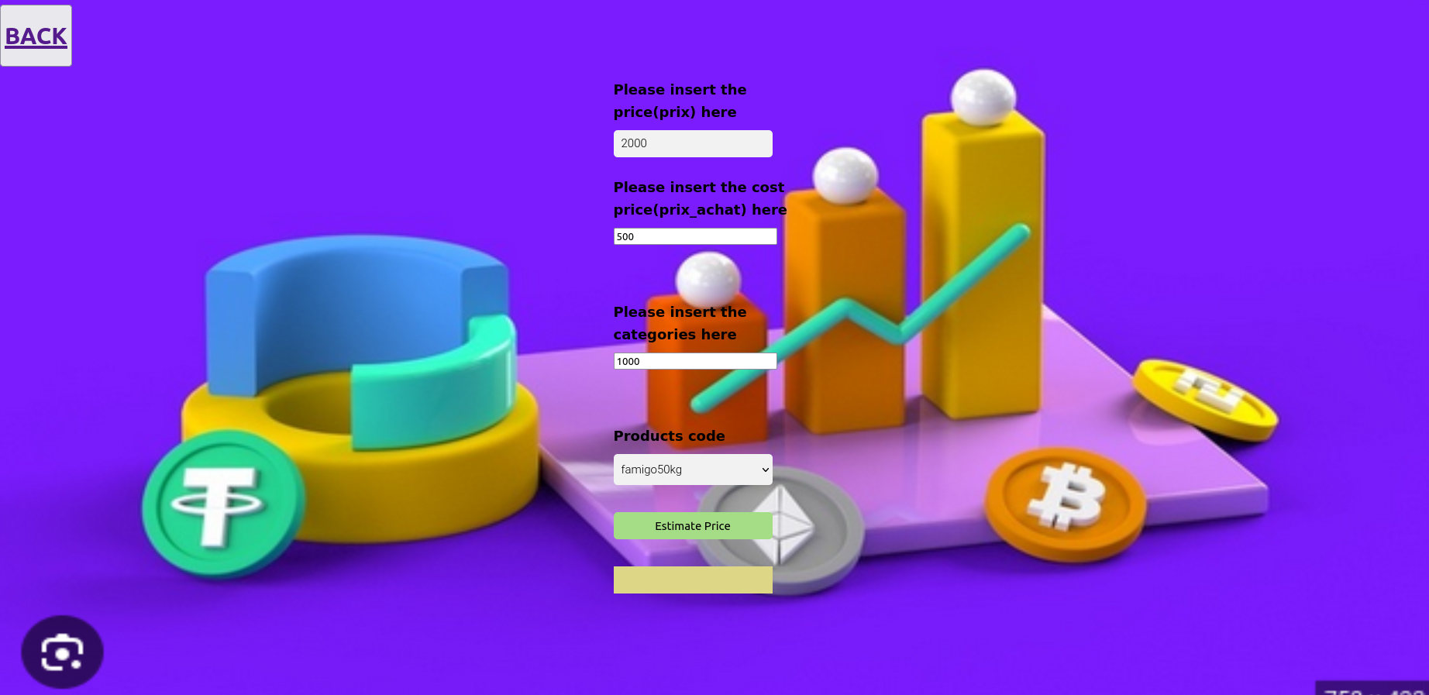This system is still used by the CEO of the enterprise. Back to the section where the CEO is able to choose between the sales forecasting and the price prediction, if his aim is to predict the prices of products, he chooses this section. Here is the interface.

Figure 59. The price deduction interface

On this interface, the manager provides the following data to be able to predict the articles’ prices; the cost price of the article, the category, the actual price, and the product codes. The model uses this information to deduce the selling price of the product identified by the product codes.

### 3.1.3. Sentiment Analysis

This section together with the chatbot section is used by the client. From the home page, the client will chose the client section if he is a customer. He either registers if he has no account yet, or login if he has. Figure 60 presents this interface.



Figure 60. Client login page

After the logon page, he will have to chose between report products if he has complain about the products bought and ask questions if he wants some information about the enterprise. Figure 61 shows this interface:

Figure 61. client’s option

If his aim here is to comment about an article, he will connect to a sentiment analyzer. Figure 62 illustrates the sentiment analyzer interface.

Figure 62. The sentiment analyzer interface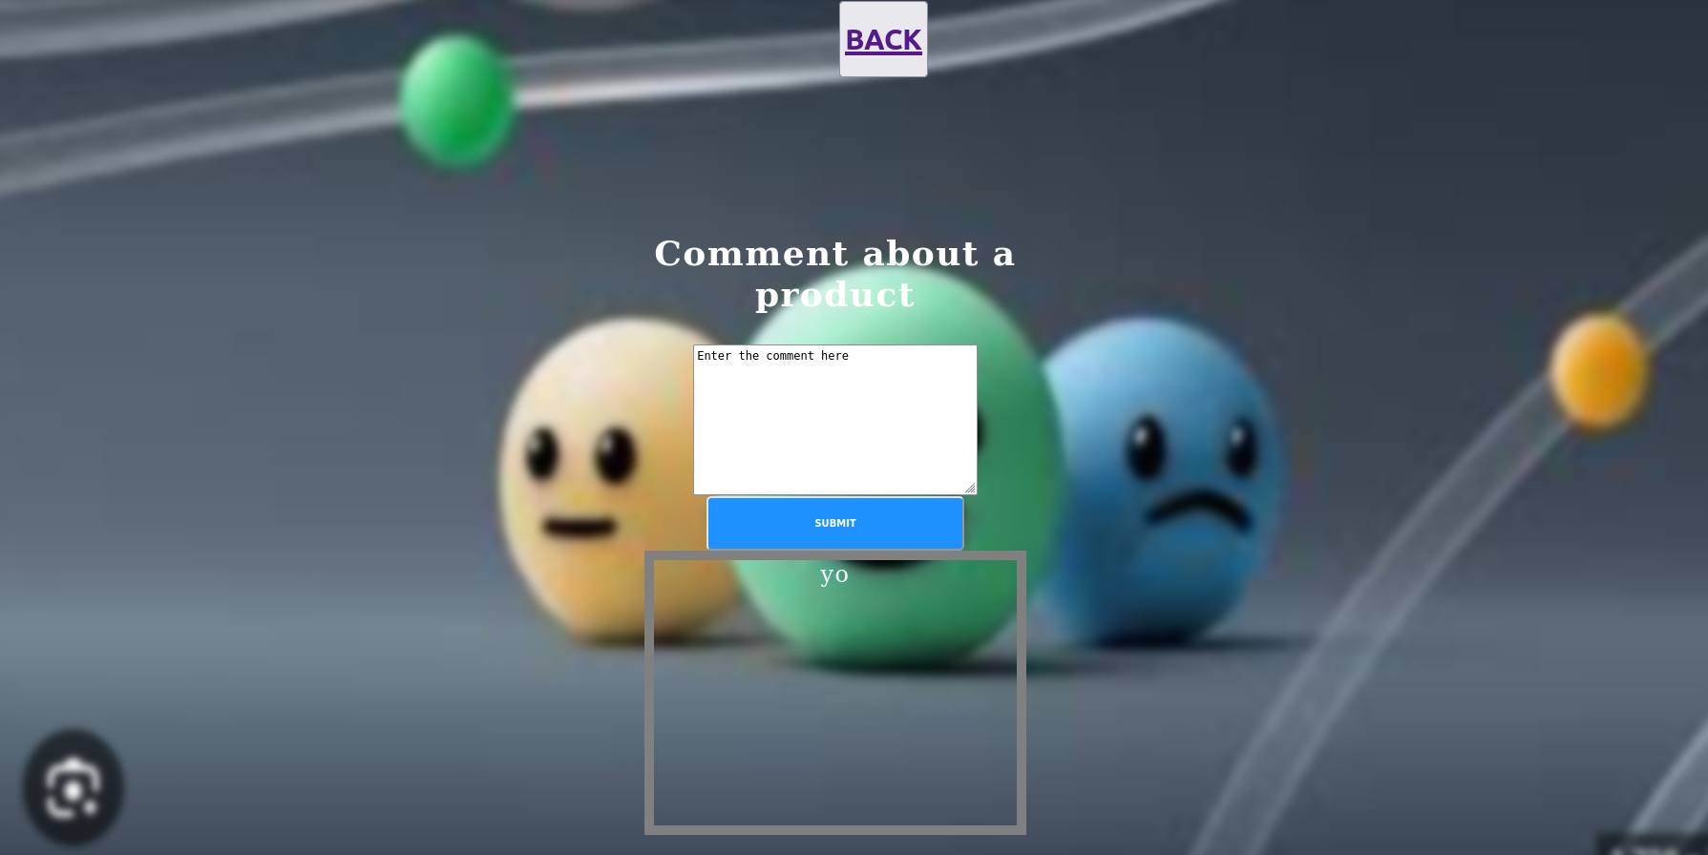

The customer will comment about the products here and the application will take this comment and send to the manager via mail if it turns out to be a negative sentiment. With this, the manager will increase the product quality.

### 3.1.4 Chatbot

This section of the application is used by the client. If the client’s option interface, his aim is to get inquiries, he will meet the chatbot where he will ask his questions and receive an automatic response.



Figure 63. The chatbot interface

The client will be able to great the chatbot and ask his questions here. These questions are particular for an enterprise.

## 3.2. General Results and Discussion

This subsection of the dissertation focuses on the overall results following from the objective based results above presented. Also, a thorough discussion of the findings of the dissertation is made in this particular subsection as well.

From chapter 2 subsection **2.1.2.2.1.** in step 3, figure 27 it was observed that:

-The mean save_prix is 6712F with the standard deviation of 11883F

-calculating the coeficient of variation(CV).

CV=EXP(DATA)/STD =6712F/11883F=0.564840528.

Which is quite low.

-this shows that the data is really spread out. That is, there are articles that contribute highly in order to improve the profit of the company whereas there are more acticles that contribute almost nothing.

-It is also observed that 50% of that products contribute the profits that is less than the mean save_prix.

From chapter 2 subsection 2.1.2.2.1**.** in step 3, figure28, we were able to get the products type that impact the save_prix(lables) greatly positively.

-it was observed that the product type '1' which are just 33 in number has a great impact to the enterprise’s benefits with the mean price of 60030F and a STD of 90566F.

-products type '0' which are plenty in number doesn't really have impact on the overall profit. It has the mean of 6524f with the std of 10173f

From chapter 2 subsection 2.1.2.2.1. in step 3, figure 29, We were able to get the first 4 products codes that give great value to the enterprise which w ere:

MRC001, COSIWE, CAIMGRD, CAMGRD.

Since the categories of the products influenced the label, it was a great idea to figure out the best categories.

From this same subsection 2.1.2.2.1 step 2, we brought up an overall insight which are as follows.

1) the products of product type 1 gives more value to the enterprise's overall profits. So, focussing on this product type will optimize her profits and makes it grow.

2)products of categories 1722,1714,1686,1320 are the categories to be foccused on to be able to optimize profits

3)products of product codes COSIWE, CAIMGRD, CAMGRD, MRCOO1 are the categories to be focused on to be able to optimise profits

4)To be able to maximize profits, products in promotion should not be highly affordable, otherwise it will bring the enterprise's profits down tremendously and that might impact the growth of the enterprise.

5)Price of products elevated if more profits is needed.

# General Conclusion

This section is the concluding section of the dissertation. It presents the summary of the findings, evaluation of the achievements and recommendations for future studies.

## 1. Summary

This dissertation aimed at approaches to company’s profit maximization. Sale forecasting, price predictions, sentiment analysis and a chatbot were explored as the techniques to achieving this aim. The RNN was used in the first experiment to build the sales forecasting model which is able to forecast the future sales based on the enterprises’ sales history. The main RNN used here was the LSTM due to it high performance. This model also brings out the best product to achieve the customer objective as well as the best client to sell it to. With this implementation, the users of the application will be able to make better sales with the help of the sales forecasting model. The section answered the research question 4 in the introduction chapter.

In the second experiment, the system of the EHSS enterprise was analyze with the use of the sklearn before building the model that is able to predict the articles’ prices. This model was made because the after the analysis, it turned out that the prices of products were varying in function of certain factors, these factors were then taken as the variable data to train the model which take as input these factors. This model is able to predicts the articles’ selling price in other to make the maximum profit on that article there by optimizing the enterprises’ profits. This model was build using the sklearn and to be precized, the Linear Regression algorithm was used here due to its excellent performance. The section answered the research question 1 in the introduction chapter. This experiment extends the work of PeerJ Comput Scit[21] because he did not implement this future.

In the third experiment, the satisfaction of the client was taken into consideration, and to do this, a sentiment analysis model was built which is able to tell if the clients are satisfied after buying a product from an enterprise. If the clients are happy, a joyful message will be displayed to him, otherwise a sad message will be displayed while notifying the manager about the product quality. With this implementation, the quality of articles was improved based on the comment received from the clients about that particular product. The NLP was the main technique used to make this possible. The section answered the research question 3 in the introduction chapter.

And finally in the last experiment, these clients are able to inquire about an enterprise and get an automatic feedback. And to make this possible, a chatbot was built. The NLP was also used in this experiments. The costumers discuss with with the chatbot as if they are actually discussing with a person. They can ask all types of questions concerning an enterprise and that chatbot is able to respond to him and give him genuine answer. The section answered the research question 2 in the introduction chapter and extended the work of Gil Maria dos Santos Romao[22]

## 2. Project cost estimation

### 4.2.1. Equipment cost estimation

The table below shows the equipements necessary to realize this project. The amount is in FCFA

|  |  |  |  |
| --- | --- | --- | --- |
| **Designation** | **Unit price** | **Quantity** | **Total price** |
| **Hardware** | | | |
| **Portable computer** | 300000 | 01 | 300000 |
| **Desktop** | 250000 | 1 | 250000 |
| **External Hard Disk** | 30000 | 01 | 30000 |
| **Modem wifi** | 50000 | 01 | 50000 |
| **Software** | | | |
| **Windows 10** | 168350 | 01 | 168350 |
| **Ubuntu** | 150000 | 01 | 150000 |
| **Others** | | | |
| **Internet connection** | 15000 | 6 (months) | 90000 |
| **Total** | | 870000 | |

**Estimation of the cost of production**

Software development is done with respect to the client‘s need. This demand is taken care of by a computer engineer. It is always important to understand perfectly the software development cost and the needs of the clients.

**Effort estimation**

The **Effort** in this context is the quantity of work that each person can realize in person-month. Generally, the effort for a month is usually considered on 20 days if the weekends are not considered as working days. The length of the project is measured with respect to its effort. The order of greatness is given with respect to the norms ISO.

* Effort e<6 person-month for a very small project
* Effort between [6 ;12] person-month for small project
* Effort between [12 ;30] person-month for medium project
* Effort between [30 ;100] person-month for big project
* Effort > 100 person-month for very large project

The duration of the project depends on the effort and the number of persons who carried out the project. Sometimes, this mode of calculation is relatively theoritical since all these people cannot work at the same rate.

The formula below permits us to estimate the effort, average staff size, productivity and the development time of the project.

$$effort b=a{\left(KLOC\right)}^{b} person-month$$

$$development time=c{\left(Effort\right)}^{d} months$$

$$Average staff size=\frac{effort}{development time} persons$$

$$productivity=\frac{KLOC}{Effort} KLOC per person-month$$

Where KLOC = Kilo Lines of Code and a,b c and d are constants whose values are different with respect to the category of the project.

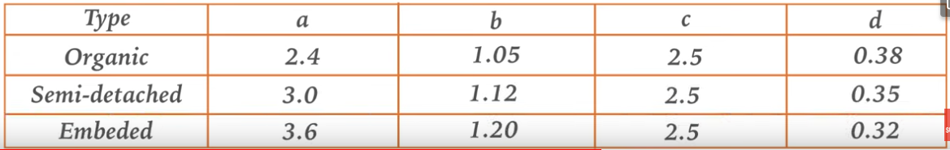

**Classification**

organic project < 50 000 lines of code

Semi-detached project : 50000<lines<300000

embeded project > 300000 lines

With respect to the COCOMO model, the project in question falls under the embedded project category since comprises of 3 01500 lines of code. We will then proceed to calculate the effort, average staff size, productivity and the development time of the project.

In this case, my a= 3.6 ; b=1.2 ; c=2.5 and d=0.32

$$effort b=a{\left(KLOC\right)}^{b} person-month$$

$$development time=c{\left(Effort\right)}^{d} months$$

Here, we our LOC = 301500

Therefore, KLOC= 301.

$effort =a{\left(KLOC\right)}^{b} person-month$

$=3.6{\left(301\right)}^{1.2} person-month$

$=3393 person-month$

$development time=c{\left(effort\right)}^{d} months$

$=2.5{\left(3393\right)}^{0.32} months$

$=33 months$

$Average staff size=\frac{effort}{development time} persons$

$=\frac{3393}{33} persons$

$=102 persons$

$productivity=\frac{KLOC}{Effort} KLOC per person-month$

$=\frac{301}{3393} KLOC per person-month$

$=0.089 KLOC per person-month$

But 1h= 6550FCFA

1h/y= 1350h

The cost = duration*1h=(33/12)*1350*6550

= 24 316875FCFA

Also, our proposition correspond to an effort of 3393 person-month and the productivity of $0.089 KLOC per person-month$

And that finally gives the cost of 24 316875FCFA

**The hand work of the engineer**

It is given by the formular :

Handwork=Te*30%

= 31 611937.5 FCFA

Where Te is the estimated cost of the project.

|  |  |  |
| --- | --- | --- |
| **Total estimate** | **Handwork of the engineer** | **Total cost of the project** |
| **24 316875** | 31 611937.5 | 55 928812.5 |

## 3. Future work

This dissertation seems to be one of the first research works geared towards approaches to optimize enterprises’ activities and profit by bringing four AI project together like the sales forecasting, price prediction, sentiment analysis and a chatbot.

One of the limitation of this project is that, even though all enterprises can use the sales forecast, price prediction and the sentiment analyses model, chatbot is an exception. Only questions from a particular enterprise is used to train the bot, and he can only answer specific questions of that enterprise. So, the chatbot section will be generalized in the future so that many enterprises can used it without not necessarily trained with their data. Also, voice assistant’s bot, will also be implemented in future so that those who cannot write will also be able to communicate with the bot via oral conversation. For the sales forecasting model, the users are only able to forecast the sales for the next month. This is a little bit disgusting if the client wants to forecast the sales ten months from now, so, making the system do this is one of the future works.

In addition, the sentiment analyses can only tell if the client is happy of not after buying a particular product, and if not happy, the manager of the enterprise will be notified via mail. This implementation is a little bit limited in one way or the other. I think it would be better if the bot discusses with the client one to one to actually know what exactly his problem is concerning that product so that after the end of the conversation, the conclusion about his need should be sent to the manager. Doing it this way will be a little bit optimal. This will be worked on in future. And finally, for the price prediction, the model can only predict prices of articles of a particular enterprise it was trained for, or if the same products are found in other enterprises with the same variability of factors, ten the model will able able to work there as well. I think making this a little general would be great. All these are the future plans of the project.

# References

|  |  |
| --- | --- |
| [1] | J. A. S. O. H. a. J. J. A. E. . Brownlee, «Exploring the Accuracy Energy Trade-off in Machine Learning,» p. doi: 10.11/gi52543.2.21.00011, 2021-11-18. |
| [2] | w. Ertel, n° %1doi: 10.1007/978-3-319-58487-4, 2017. |
| [3] | A. D. a. N. R. S. Das, «Application of Artificial Intelligence in Machine Learning: Review and Prospect,» *Int. J. Comput. Appl,,* vol. 115, n° %19, pp. 975-8887, 2015. |
| [4] | «ehss sarl database,» 2017-2023. |
| [5] | Anaplan, «Begginner's guide to sales forecasting methodology,» pp. doi: 10.2007/978-4-359-58487-4, 2020. |
| [6] | N. J. Nilsson, «Principles of Artificial Intelligence,» Vols. %1 sur %2PAMI-3, n° %11.1981. |
| [7] | M. L. a. D. Mining, «Machine Learning: Trends, perspectives, and prospects,» vol. 12, n° %1Com 5318, pp. 3-12, 2017. |
| [8] | M. I. J. a. T. .. Mitchell, «Machine learning: Trends perspectives and prospects.,» vol. 349, n° %16245, pp. 255-260, July-2015. |
| [9] | V. bansal, «the deep history of deep learning,» April 2020. [En ligne]. Available: https://www.geeksforgeeks.org/introduction-to-recurrent-neural-network/. |
| [10] | aishwarya.27, «introduction to recurent neural network,» 18 may 2023. [En ligne]. Available: https://dlabs.ai/blog/price-prediction-how-machine-learning-can-help-you-grow-your-sales/. |
| [1] | k. Rojewska, «price prediction how machine learning can help you grow your sales,» vol. 52, n° %11, pp. 127-138, 21-02-2023. |
| [12] | javatpoint, «linear regression in machine-learning,» 2022. |
| [13] | R. Pupale, «medium com pupalerushkesh svm,» 16 june 2018. [En ligne]. Available: https://towardsdatascience.com/https-medium-com-pupalerushikesh-svm-f4b42800e989. |
| [14] | J. M. J. T. a. B. B. M. Binder, «Multi-objective hyperparametre turning and feature selection using filter ensemple,» 2020. [En ligne]. Available: https://www.javatpoint.com/k-means-clustering-algorithm-in-machine-learning. |
| [15] | S. Gupta, «sentiment-analysis-concept-analysis-and-applications-6c94d6f58c17,» 07 Jan 2018. [En ligne]. |
| [16] | B. V. a. J. Anuaradha, «a review of feature selection and its methods cybern. Inf. Technol.,» *doi: 10.2478/CAIT-2019-0001.,* vol. 19, n° %11, pp. 3-26, 2019. |
| [17] | deeplearning.AI, «deeplearning.ai resources natural language processing,» 11 Jan 2023. [En ligne]. |
| [18] | IBM, «ibm.com/topics/chatbots,» [En ligne]. Available: https://www.ibm.com/topics/chatbots. |
| [19] | D. C. J. D. S. a. D. M. J. M. L. R. E. Cai, «NeuralPower: Predict, and deploy energy-efficient convoultional neural networks.,» 2017. [En ligne]. Available: https://www/towardsdatascience.com/convolutional-neural-networks-explained-9cc5188c4939. |
| [20] | N. K. B. D. E.-H. A. Yves R Sagaert, «Tactical sales forecasting using a very large set of macroeconomic indicators,» p. doi:10.1016/j.ejor.2017.06.054, June-2017. |
| [21] | S. U. J. A. S. PeerJ Comput Sci, «News Sensitivit stock market prediction,» doi:10.77.17/peerj-cs.490, 4 may 2021. [En ligne]. Available: https://www.ncbi.nlm.nih.gov/pmc/articles/PMC8114814/. |
| [22] | Gil Maria dos santos Romao, «chatbots in education: Intelligent chat agent,» June 2021. [En ligne]. Available: https://www.researchgate.net/publication/352384737_A_Literature_Review_on_chatbots_in_education_An_intelligent_chat_agent. |
| [23] | daffodilsw, «insights.daffodilsw.com/blog/pros-and-cons-of-using-the-tensorflow-ml-platform,» [En ligne]. |
| [24] | M. Rouse, «Natural Language Toolkit,» 26 June 2023. [En ligne]. Available: techopedia.com/definition/30343/natural-language-toolkit-nltk. |
| [25] | toaedsdatascience. [En ligne]. Available: towardsdatascience.com/creating-restful-apis-using-flask-and-python-655bad51b24.. |
| [26] | g. learning, «Flask Vs Django: which Python framework to choose,» 6 sept 2022. [En ligne]. Available: www.mygreatlearnin g.com/blog/flask-vs-django/. |
| [27] | D. Ellis, «what is Anaconda for python and why shoukd you learn it?,» 03 Nov 2022. [En ligne]. Available: . blog.hubspot.com/website/anaconda-python. |
| [28] | Postman.com, «The future is API-first,» [En ligne]. Available: www.google.com/search?channel=fs&client=ubuntu&q=what+is+postman+api. |
| [29] | Austin, «what is Microsft Visio and ahzt does it do?,» 22 July 2021. [En ligne]. Available: www.google.com/search?q=what+isMicrosoft+Visio&client=ubuntu&hs=pEz&channel=fs&sxsrf=AB5stBhjug3RjxOY-wz4v0M8SKB3nlPzHA. |
| [30] | hostinger, «what is CSS and how does it work,» 15 May 2023. [En ligne]. Available: hostinger.com/tutorials/what-is-css. |
| [31] | du.edu. [En ligne]. Available: /www.bu.edu/lernet/artemis/years/2020/projects/FinalPresentations/HTML/historyofhtml.html. |
| [32] | microsoft. [En ligne]. Available: /learn.microsoft.com/en-us/power-bi/fundamentals/desktop-what-is-desktop. |
| [33] | jetbrains. [En ligne]. Available: .jetbrains.com/help/pycharm/quick-start-guide.html.. |
| [34] | infoworld.com. [En ligne]. Available: infoworld.com/article/3666488/what-is-visual-studio-code-microsofts-extensible-code-editor.html [1]. |

Appendix 1 – Sample Epochs Validation and the Learning Rate Implementation Code

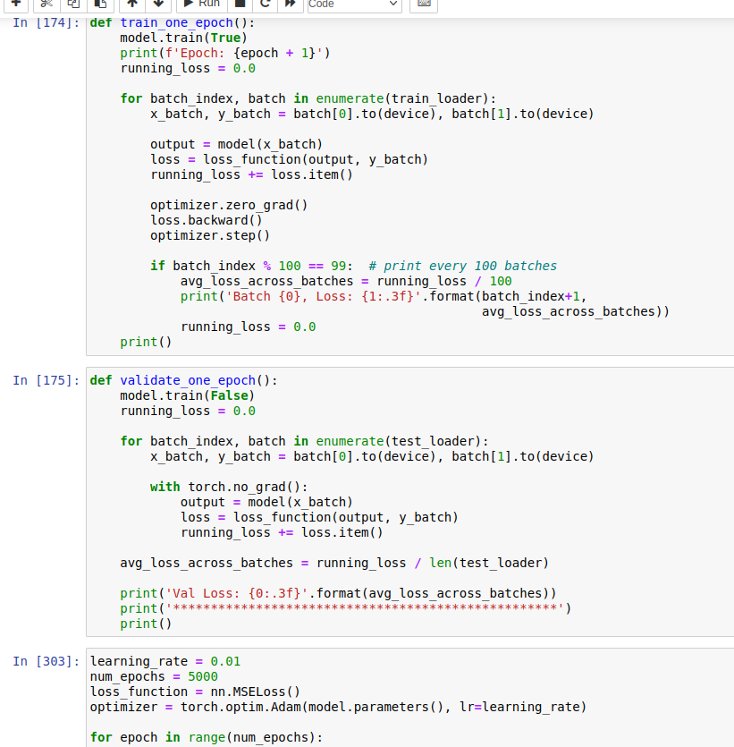

Appendix 2- Sample model selection Implementation Code

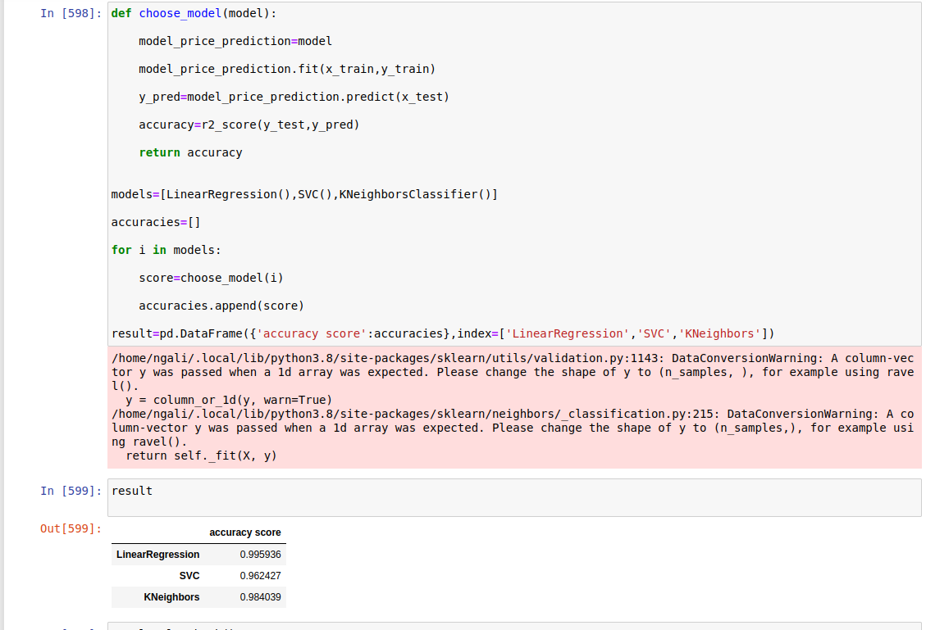

Appendix 3- Sample tokenization and lemmatization Implementation Code

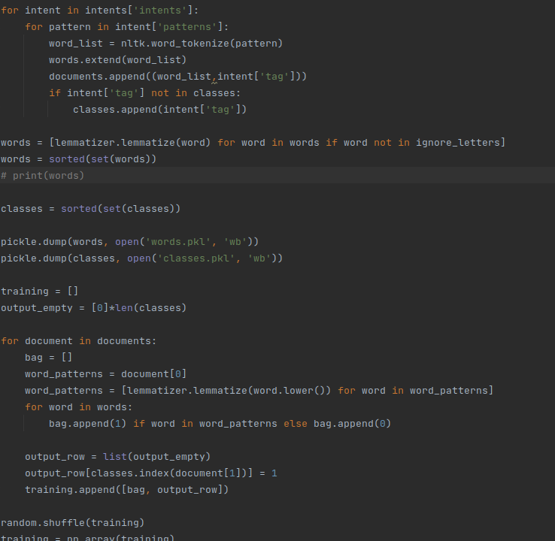

Appendix 4- Sample **chatbot UI** Implementation Code

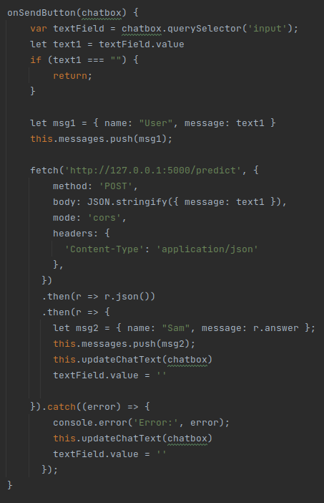

Appendix 5- Sample **chatbot API** Implementation Code

